Artificial Intelligence Notes
Lecture 01
What is AI?
AI (Artificial Intelligence) is when computers are made smart enough to do things that usually need human thinking, like learning, solving problems, understanding language, and recognizing pictures. It helps machines act more like humans.
Think like humans and act like humans?
Think Like People
- AI tries to copy human thinking (learning, problem-solving, memory).
- Example: ChatGPT learns from conversations like a human.
Act Like People
- AI behaves like a human (talking, recognizing faces, driving cars).
- Example: Robots like Sophia can talk and express emotions.
Think Like Rationally and Act Like Rationally?
Think Rationally
- AI follows logic and reasoning to make the best decisions instead of emotions or guesses.
- Example: Chess AI analyzes moves and picks the smartest one.
Act Rationally
- AI makes smart choices to achieve goals efficiently.
- Example: Self-driving cars follow traffic rules to avoid accidents.
Perspective on AI:
Perspective: Means different ways of looking at or understanding something.
- Skill Based Perspective
This perspective says that intelligence is about getting better at specific tasks. It focuses on practical abilities rather than general thinking.
Example:
Imagine you are learning how to fix a car.
- At first, you don’t know much.
- Over time, you practice and improve.
- Eventually, you can fix any car problem easily.
That means you have gained intelligence in car repair—because you learned and mastered a skill.
In short:
Skill-Based Perspective = Intelligence is about getting better at tasks like fixing cars, coding, or playing chess.

- Embodiment Perspective
This idea suggests that intelligence requires a body to interact with the real world. It believes learning happens through physical experiences, not just thinking.
Example:
A robot learning to walk

- A robot can't just learn to walk by watching videos or simulations.
- It must physically try walking, fall, adjust, and learn from experience.
- This means intelligence isn't just in the brain, but in physical actions too.
Summary:
Learning is more effective through physical experiences, not just theory.

- Psychometrics Perspective (Measuring Intelligence)
This perspective measures intelligence using tests like IQ tests. It focuses on numbers and scores to understand mental abilities.
Example:
IQ Test
- A test that checks memory, problem-solving, and language skills.
- If someone has an IQ score of 140, they are considered very intelligent.
Summary:
This perspective sees intelligence as something that can be measured using scores.
- Human-Compatible Perspective (AI Should Help Humans)
This perspective focuses on creating AI that understands and helps humans safely and effectively. The goal is to build machines that align with human needs and values.
Example:
Virtual Assistants (Siri, Google Assistant)
- These AI tools listen to human commands and assist with daily tasks.
- They are designed to be useful and safe, rather than making decisions on their own.
Summary:
AI should be designed to work with humans and assist them safely.

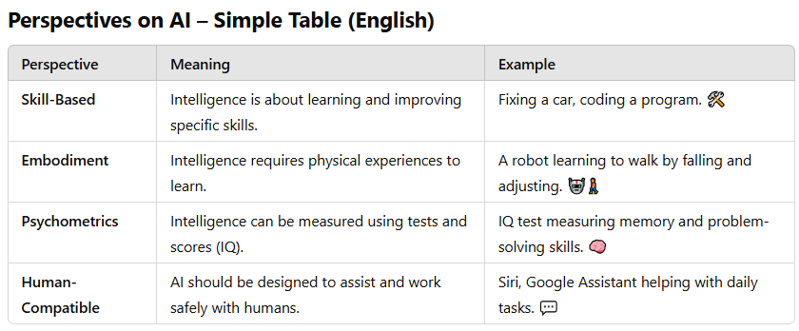

Understanding the Brain & AI
Brains are good but not perfect at rational thinking
- Humans can make smart decisions, but sometimes we make mistakes due to emotions or biases.
Brains Are Complex, Not Like Software
- Software is like LEGO blocks—you can break it into small parts, fix one piece, and put it back together.
- The brain is like a tangled ball of wires—everything is connected, so you can’t easily take out or fix just one part.
- In simple words the brain is not built in separate sections like software—everything works together, making it hard to understand or copy.

AI is better than humans in some tasks
- AI can calculate faster, store more data, and work non-stop.
- Example: Chess AI beats human champions because it processes millions of moves in seconds
Brains vs. AI is like Wings vs. Flight 🦅✈️
- Birds use wings to fly, but airplanes fly differently and even better in some ways.
- Similarly, AI doesn’t need to work exactly like a human brain to be intelligent.
We can’t build AI as powerful as the brain (yet!) 🚀
- The human brain has around 86 billion neurons, and AI is not that advanced yet.
- But we keep improving AI models over time.
The Brain is a great inspiration for AI 💡
- Even though AI is different, scientists study the brain to make better AI systems.
History of AI
1940-1950: Early days: neural and computer science meet
- 1943: McCulloch & Pitts: Boolean circuit model of brain
- 1950: Turing's “Computing Machinery and Intelligence”
1950—70: Excitement! Logic-driven
- 1950s: Early AI programs, including Samuel's checkers program, Newell &
- Simon's Logic Theorist, Gelernter's Geometry Engine
- 1956: Dartmouth meeting: “Artificial Intelligence” adopted
- 1965: Robinson's complete algorithm for logical reasoning
1970—90: Knowledge-based approaches
- 1969—79: Early development of knowledge-based systems
- 1980—88: Expert systems industry booms
- 1988—93: Expert systems industry busts: “AI Winter”
1990—: Statistical approaches
- Resurgence of probability, focus on uncertainty
- General increase in technical depth
- Agents and learning systems… “AI Spring”?
- 1996: Kasparov defeats Deep Blue at chess
- 1997: Deep Blue defeats Kasparov at chess
2010-2017: Big Data, GPUs, Deep Learning
- 2011: Apple releases Siri
- 2012: Alex-Net wins ImageNet competition
- 2015: DeepMind achieves “human-level” control in Atari games
- 2016: DeepMind’s AlphaGo defeats Lee Sedol at Go
- 2016: Google Translate migrates to neural network
2017—: Scaling Up, Large Language Models
- 2017: Google invents Transformer architecture
- 2017: Deep-Stack/Libratus defeat humans at poker
- 2018-2020: AlphaFold predicts protein structure from amino acids
- 2021-2022: Modern text-to-image generation
- 2022: OpenAI releases ChatGPT
- 2024: Every other company also releases a chatbot
Lecture 02
Agent:
An agent is anything that can sense its surroundings and take actions based on what it senses.
Sensors = Eyes & Ears 👀👂
- These help the agent see, hear, or detect what’s happening.
- Example: A self-driving car has cameras, radar, and GPS as sensors.
Actuators (Effectors) = Hands & Feet 🤖🏃‍♂️
- These let the agent take action and change things in the environment.
- Example: A robot’s wheels or arms help it move or pick up things.
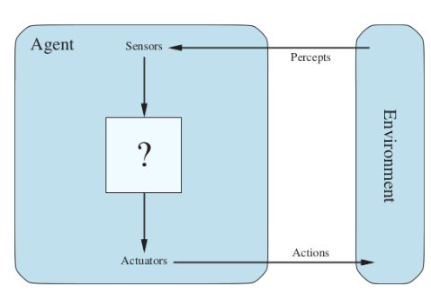
Types of Agents:
- Human Agent:
A human agent has sensory organs such as eyes, ears, nose, tongue and skin parallel to the sensors and other organs such as hands, legs, mouth, for effectors.
- Robotic Agent
A robotic agent uses cameras and infrared sensors to see and detect objects, just like human eyes. It uses motors and other moving parts to act and move, just like human hands and legs.
- Software Agent
A software agent gets input from the keyboard, files, or internet data (just like human senses 👀). It acts by showing things on the screen, saving files, or sending messages over the internet (like speaking or writing ✍️).
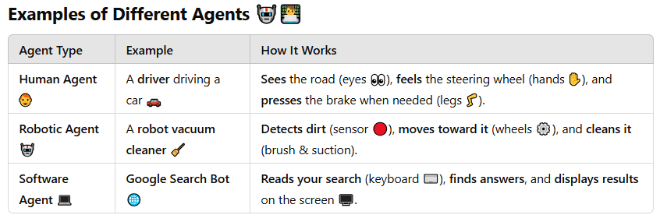
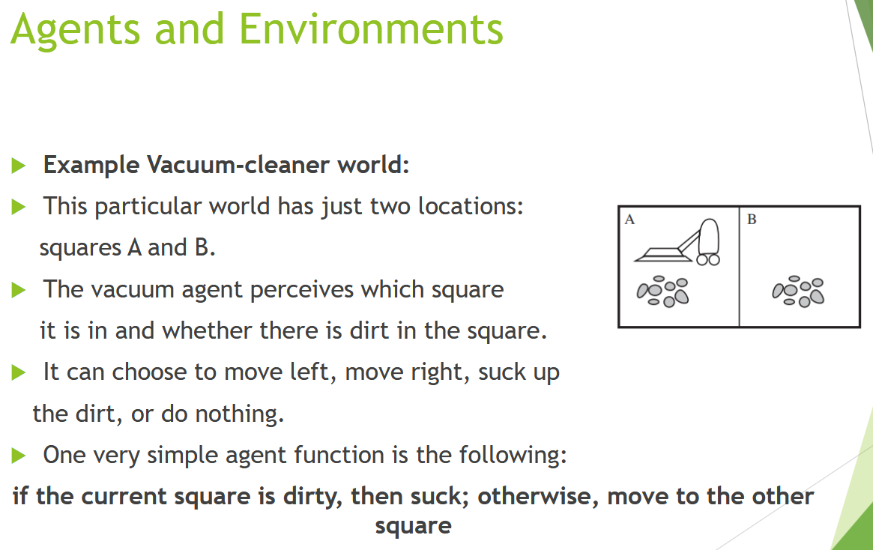
Concept of Rationality (in Simple Words)
Rationality means making the best possible decision based on what you know to achieve a specific goal. A rational agent is one that does the "right thing" in a given situation.
But what does "right thing" mean here? 🤔
It doesn’t mean perfect decision-making—it means making the best decision based on the available information, past experience, and the agent’s goals.
Example:
Imagine you're playing a video game where you need to avoid obstacles and collect coins.
- If you see a coin and move toward it, that’s rational.
- If you see an obstacle and avoid it, that’s rational.
- If you ignore a coin or hit an obstacle when you could have avoided it, that’s not rational.
In short: Rationality means taking actions that help you win the game using what you know.
COR (Continue):
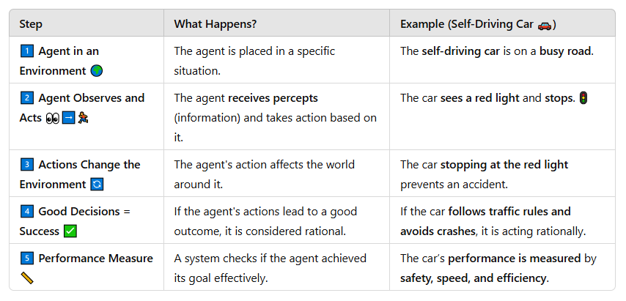
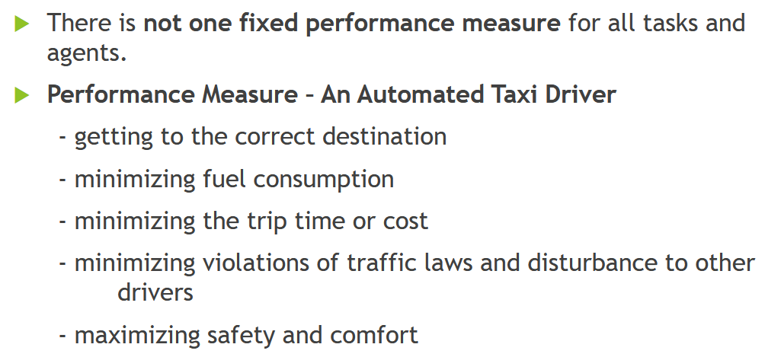

Rational Agent:
A rational agent is a system that always tries to make the best decision based on the information it receives. It observes its surroundings (percepts), processes this information, and then selects the most effective action to achieve the best possible result. The agent uses both its current observations and any built-in knowledge it already has to make smart choices. Its goal is to maximize success by taking actions that lead to the best performance.
Example:
A self-driving car detects a red light, knows from its training that stopping is the safest option, and applies the brakes to avoid accidents. This decision-making process ensures that the agent behaves logically and efficiently in any given situation.
What is Task Environment?
The Task Environment is everything an agent interacts with and operates within to achieve its goals. It includes:
- The world around the agent (the environment).
- The tasks it needs to accomplish.
- The tools it uses to perceive and act (sensors & actuators).
PEAS Framework (to define task environments)
PEAS stands for:
- P – Performance Measure: How we measure success.
- E – Environment: The surroundings the agent works in.
- A – Actuators: Parts that act or change the environment.
- S – Sensors: Parts that perceive or gather information.
🚗 Example: Self-Driving Car
- Performance Measure: Safe, efficient, and legal driving.
- Environment: Roads, traffic, weather conditions.
- Actuators: Steering, brakes, accelerator.
- Sensors: Cameras, GPS, radar.
The task environment guides the agent’s behavior based on these elements.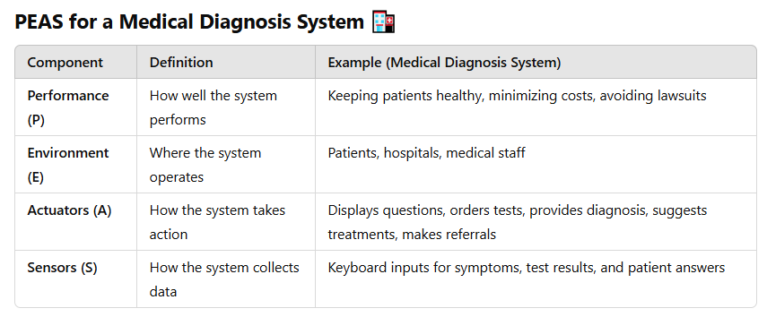
Properties of Task Environment:
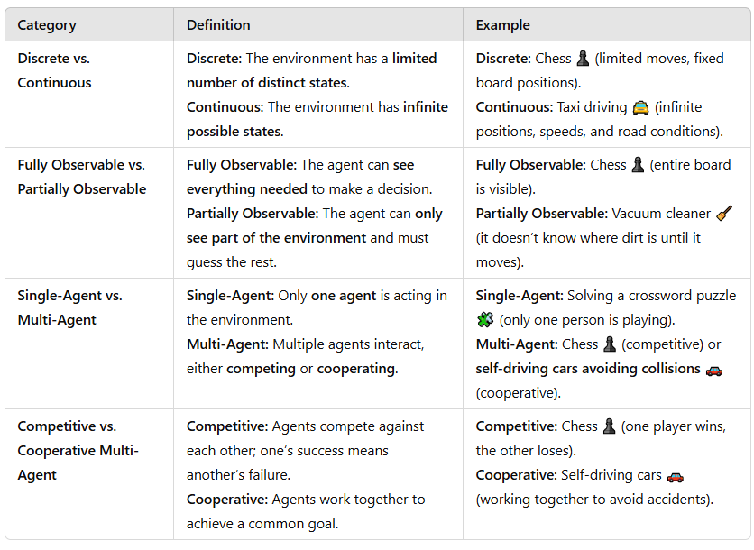
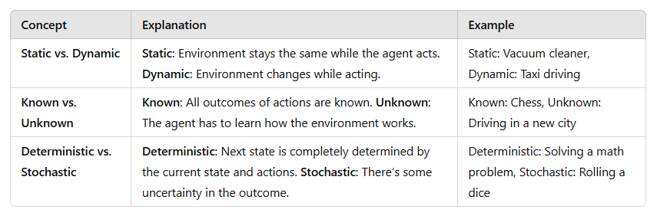
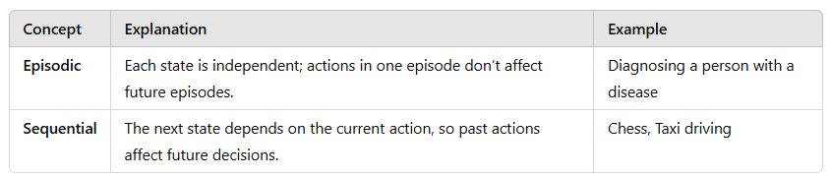
Structure of Agents:
Agent = Architecture + Program
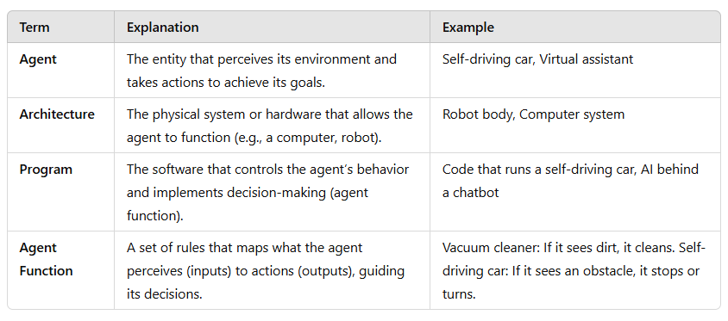
AI’s job is to create an agent program that defines how the agent decides which actions to take based on its percepts (inputs from the environment). This program ensures the agent acts in a way that aligns with its goals.
Architecture:
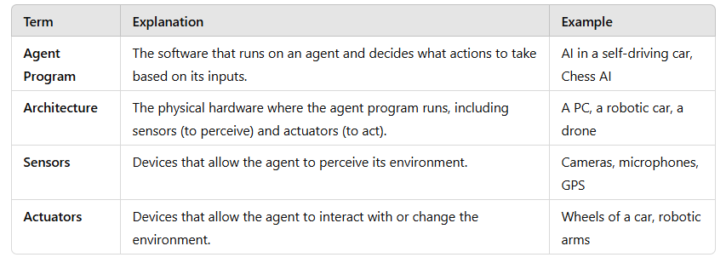

The Structure of Agents – Table Driven
A Table-Driven Agent works like a big lookup table. It remembers everything it has seen (percept sequence) and checks a table to decide what to do next.
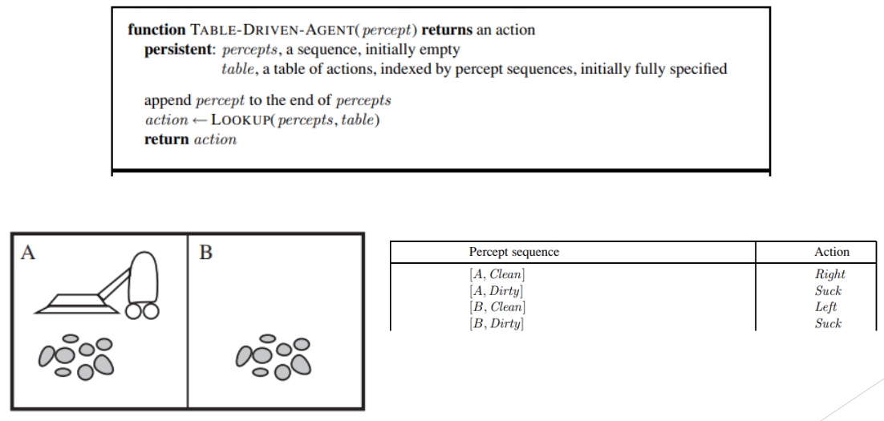
Key Point from Above figure
- Percept: What the agent sees at a moment (e.g., [A, Dirty]).
- Sequence: A list of all past percepts the agent remembers (e.g., [A, Dirty], [A, Clean]).
- Actions: What the agent does based on percepts (e.g., Suck, Move Right).
- Append: Adding a new percept to the sequence (e.g., Adding [B, Dirty] to the list [A, Dirty], [A, Clean]).

Types of Agents:
Simple Reflex Agent
A Simple Reflex Agent works by reacting to what it senses in the environment, without thinking about what happened before. It follows a simple cycle: first, it senses the environment using sensors. Then, it checks a set of rules to decide what action to take. After deciding, it performs the action and repeats the process.
- Example: in the case of a vacuum cleaner, if it senses dirt, it starts cleaning. If the room is clean, it moves to the next room.
- However, the limitation of a simple reflex agent is that it doesn’t remember past actions or learn from them—it simply reacts to the current situation.
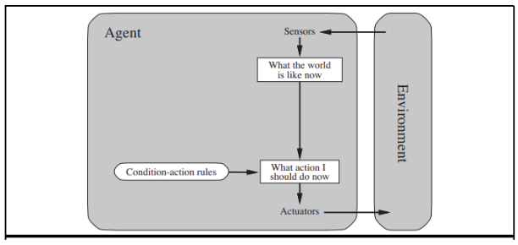
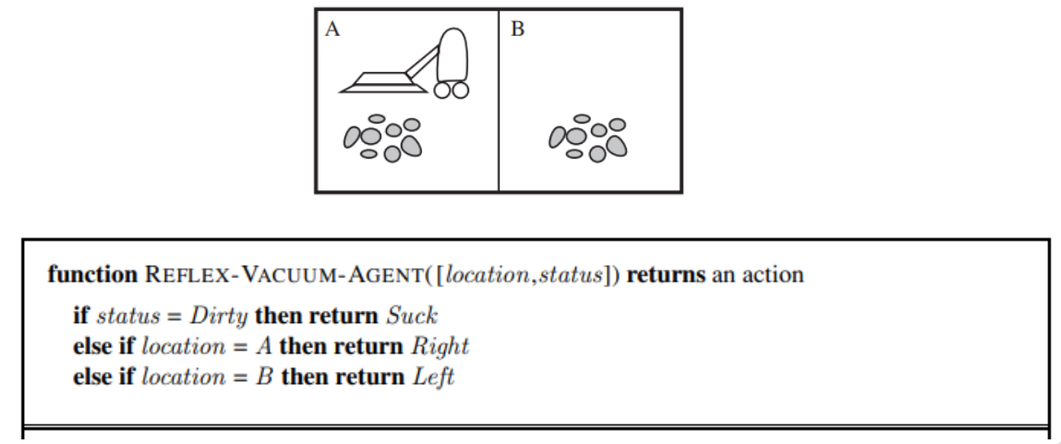
Strengths:
- Simple and easy to implement
- Fast and efficient
- Suitable for well-defined environments
Weaknesses:
- Limited adaptability
- Require a fully observable environment
Model Base Agent
A model-based reflex agent is like a simple reflex agent but with an internal memory of the environment. It can remember past information and use that to make better decisions, especially when it can't see everything around it. This helps the agent react appropriately even if it only has partial information at the moment.
- Example: A self-driving car is a model-based reflex agent. It uses sensors to make decisions, like stopping at a traffic light. If the light is blocked, it remembers the last light color and acts accordingly, even when it can't see the light directly. This helps the car react more intelligently in situations where it doesn’t have complete information.
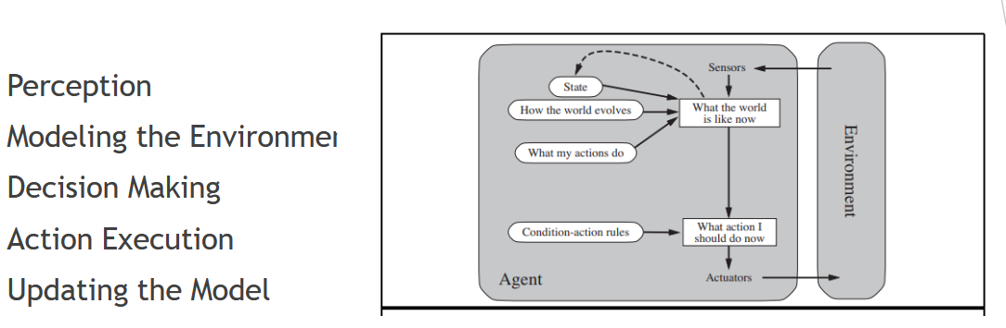
Strengths:
- Handle partially observable environments
- Flexible
- Use internal model to make predictions
Weaknesses:
- Complex
- Relies on internal model
- Limited Learning
Goal Based Agent
A goal-based agent is an extension of a model-based agent, but with an added focus on achieving specific objectives. These agents don’t just react to their environment—they actively plan their actions to reach a goal. They have a clear target or purpose, and they decide the best way to achieve it based on their knowledge and models of the environment.
- For example, a navigation system is a goal-based agent. Its goal is to find the best route to a destination. It constantly evaluates the environment, plans the next steps, and adjusts its actions based on traffic, road conditions, and the destination, ensuring it moves toward the goal efficiently.
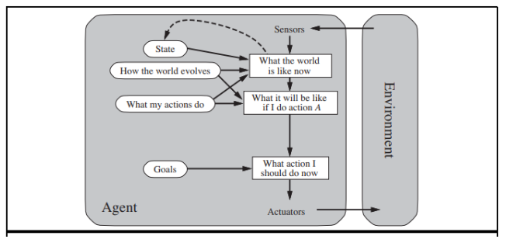
Strengths of Goal-based Agents:
- Adaptability: They can change their behavior depending on the situation, helping them reach their goal even when things change around them.
- Handling Multiple Outcomes: They work well in situations where there are different possible results, making them good for more complicated tasks.
Weaknesses of Goal-based Agents:
- Computationally Expensive: They need a lot of resources to plan and decide the best actions, which can make them slower or more demanding to run.
- Complexity: They are harder to design because they have to plan, make decisions, and keep track of goals all at once.
- Fully Observable Environment: They need to see everything happening in the environment to make the best decisions, so they struggle in situations where they can’t observe everything.
Utility Based Agent:
These agents are like goal-based agents but include utility measurement, allowing them to evaluate and compare different options to choose the best one. This is useful in complex scenarios with multiple alternatives.
- An example of an agent using utility is a shopping assistant in an online store. When you want to buy something, the assistant looks at different products and compares them based on things like price, customer reviews, how quickly they can be delivered, and features. It then recommends the product that gives you the best overall value, based on all these factors.
Strengths of Utility-based Agents:
- Flexible and Adaptive: They can adjust their decisions based on changing circumstances and preferences.
- Incorporate Preferences: They can consider the agent’s priorities, like choosing a faster delivery or a cheaper product, when making decisions.
Weaknesses of Utility-based Agents:
- Complex: They are harder to design because they need to evaluate many factors.
- Computationally Expensive: They require more computing power to compare all the options and calculate the best one.
- Uncertainty: They can struggle when there is uncertainty or lack of information, making it harder to make perfect decisions.
Lecture 04
State Space in AI
In Artificial Intelligence (AI), state space refers to all possible configurations a problem can have. AI systems use state spaces to model problems and find solutions using search algorithms.
Key Elements of State Space in AI:
- Initial State → The starting point of the problem.
- Goal State → The desired outcome or solution.
- Operators (Actions) → The possible moves or transformations from one state to another.
- Path Cost → The cost of reaching a state (if applicable).
- Search Space → The subset of states explored to find the goal.
Example in AI: Solving a Puzzle
🔹 Problem: Solving an 8-puzzle game.
🔹 State Space: All possible board configurations.
🔹 Initial State → The scrambled (random) starting position.
🔹 Goal State: The correctly arranged puzzle.
🔹 Operators: Moving tiles up, down, left, or right.
🔹 Search Algorithm: AI uses BFS, DFS, A*, etc., to find the best path.
State Space Representation in AI
- Graph Representation → Each state is a node, and edges show possible moves.
- Tree Representation → If no state is revisited, AI uses a tree structure.
Role in AI Search Algorithms
AI search methods explore the search space to find solutions efficiently:
- Uninformed Search: BFS, DFS (blindly explore).
- Informed Search: A* Algorithm, Greedy Search (use heuristics to find the best path).

What is Search Space? (Simple Explanation)
Search space is the part of the state space that an AI actually explores to find a solution.
- State Space = All possible situations (too big to check everything).
- Search Space = The specific paths AI explores to reach the goal.
Search Space is divided into three regions:
- Explored = Paths you've already walked.
- Frontier\Fringe = Paths you're considering next.
- Unexplored = Paths you haven’t tried yet.

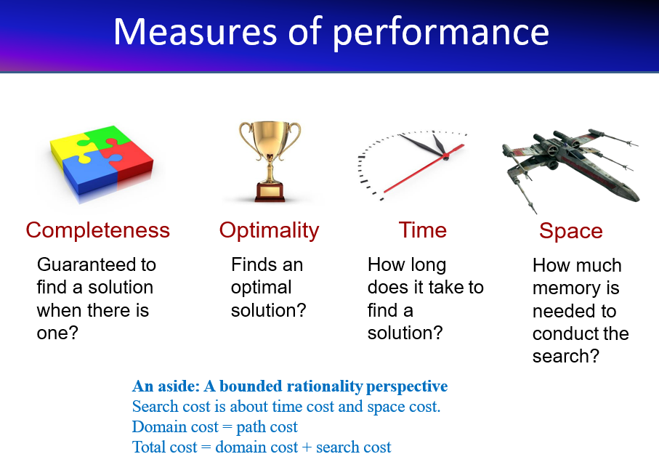
- Path Cost → The total cost of moving from the start state to the goal state
- Search cost = Time spent figuring out the best route.
- Other factors = Time, memory, complexity, heuristics, and real-world obstacles.
- Domain cost = Overall difficulty of solving the problem, including all above factors.
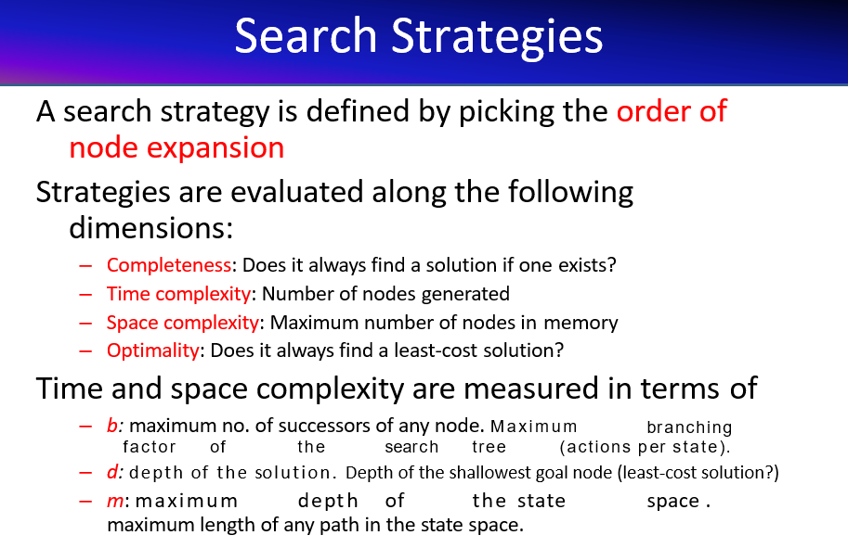
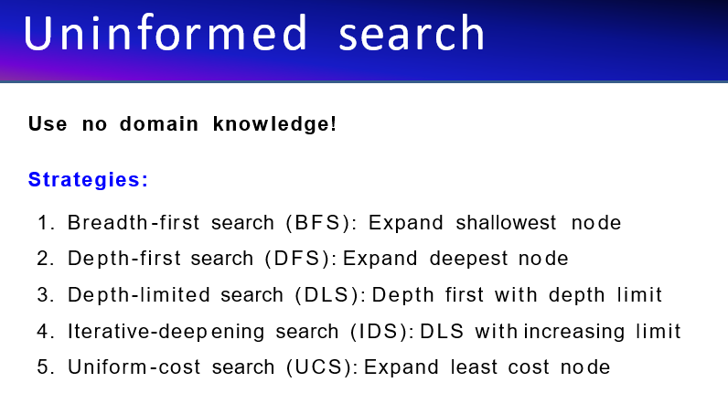

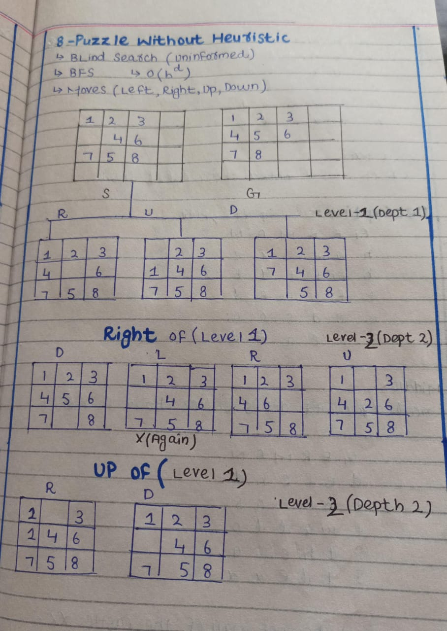
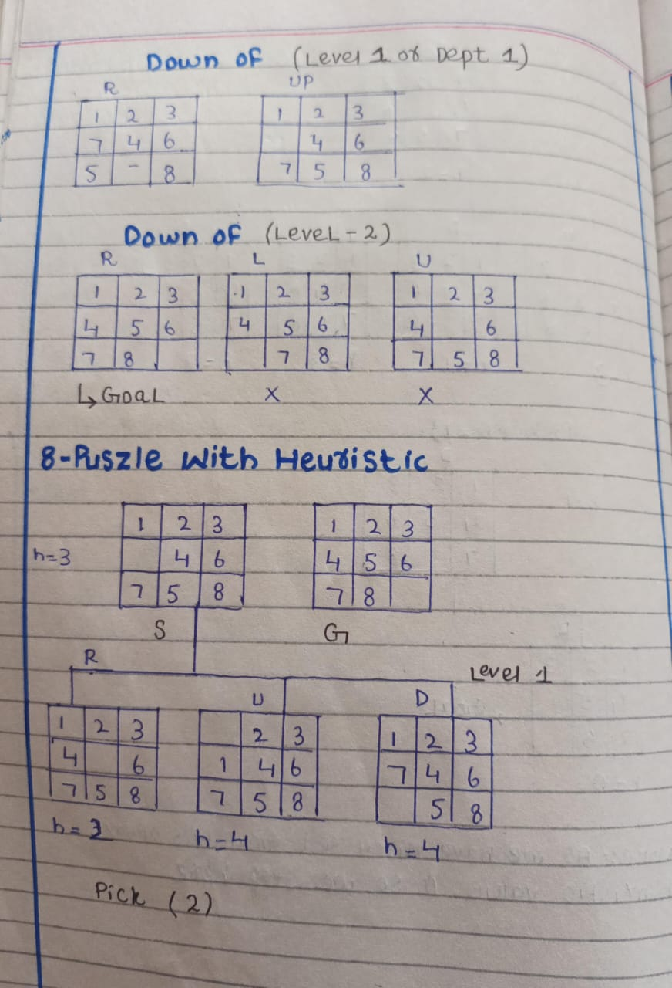
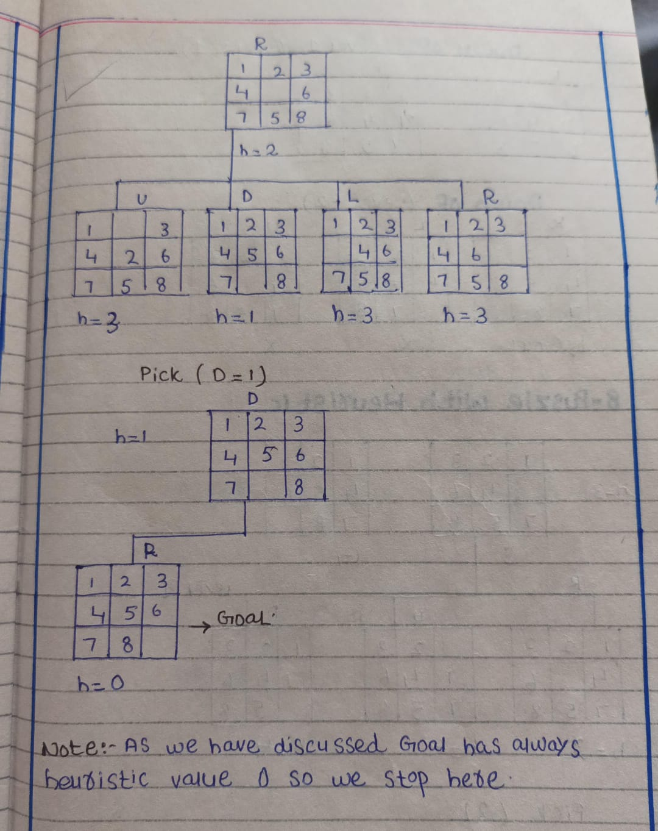
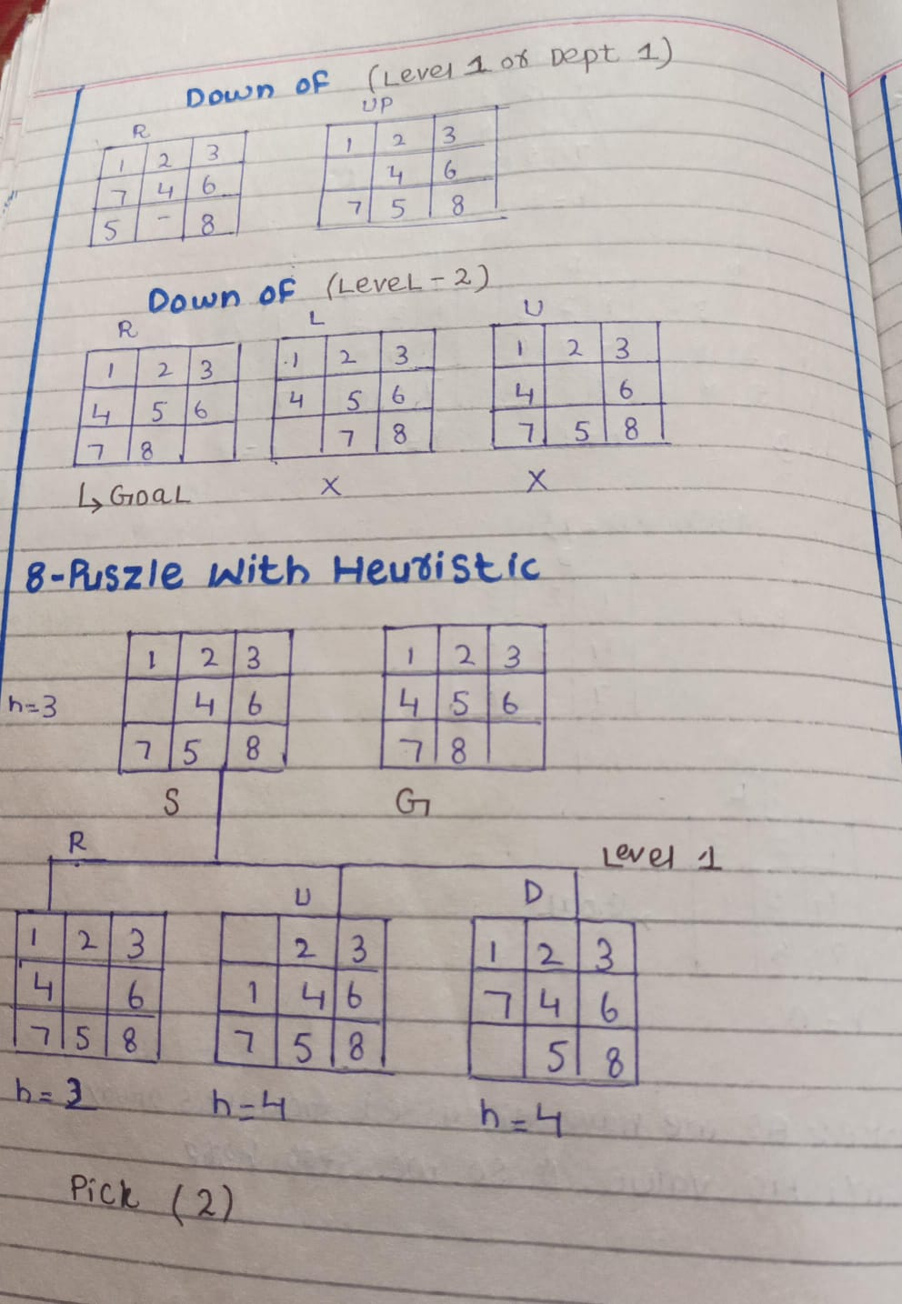
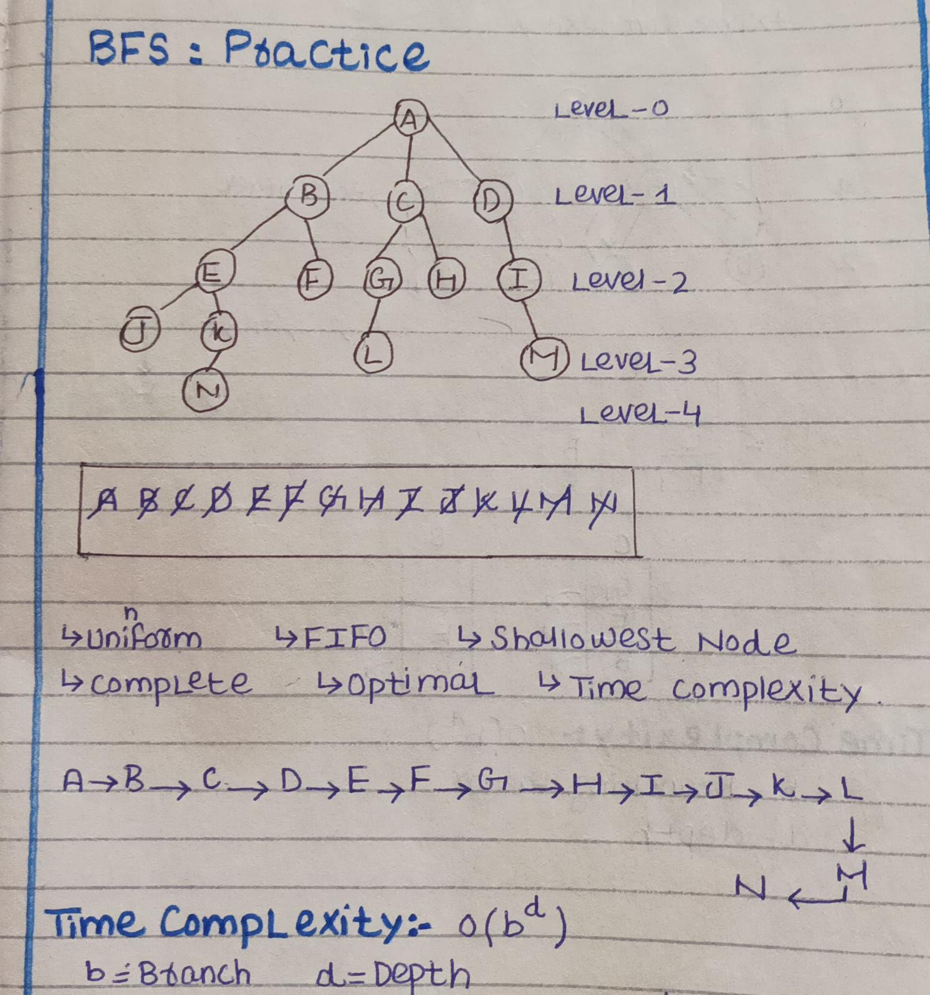

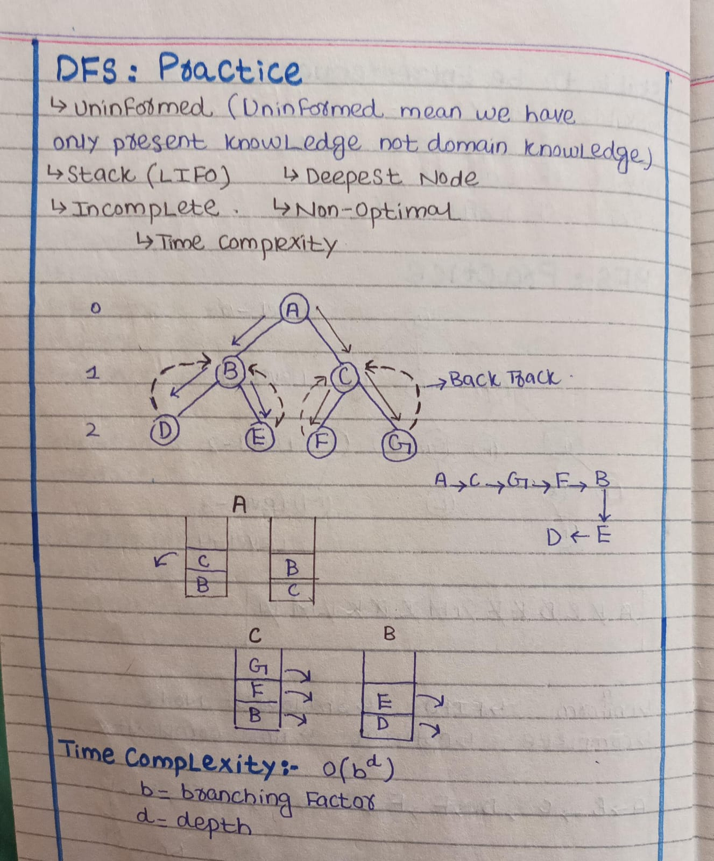

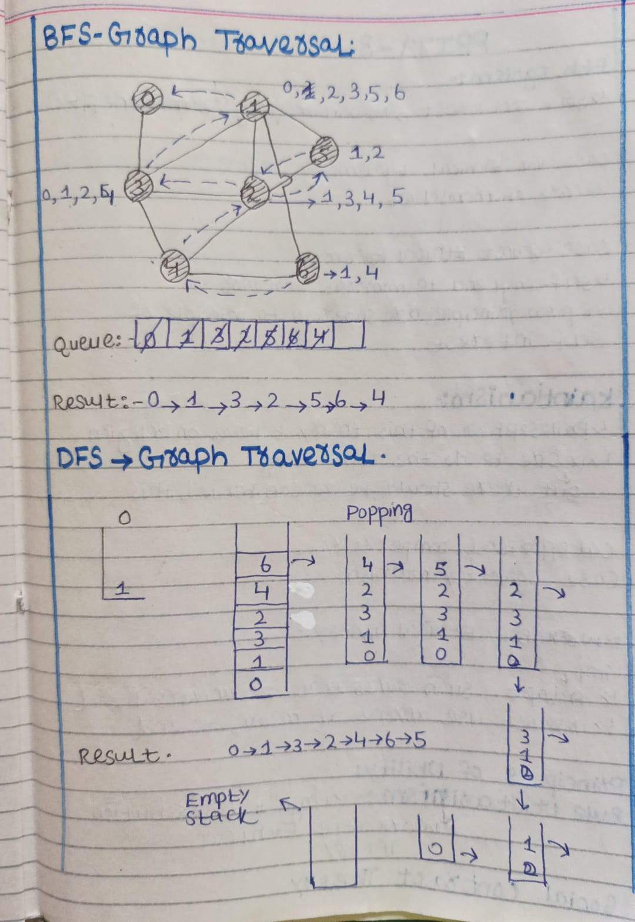
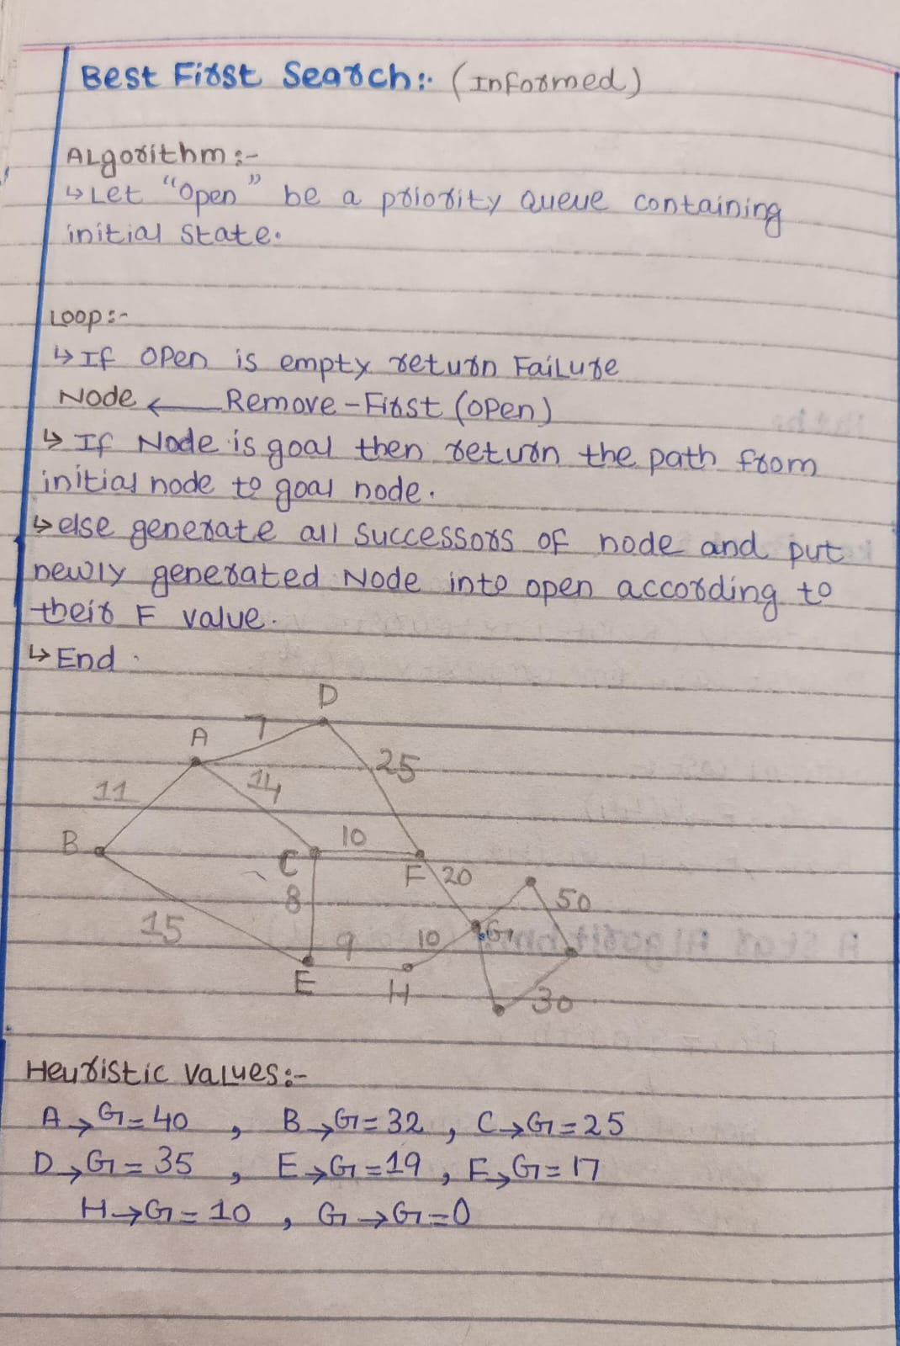
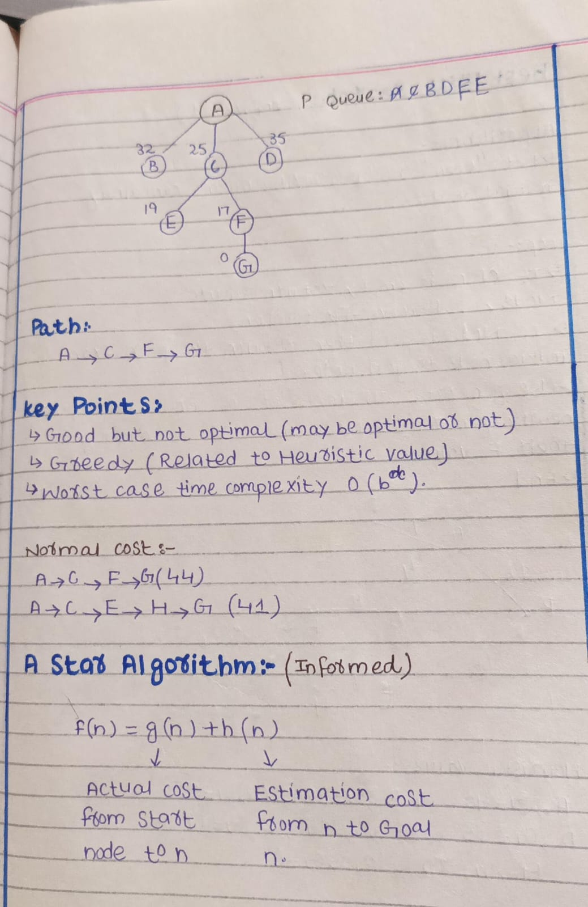
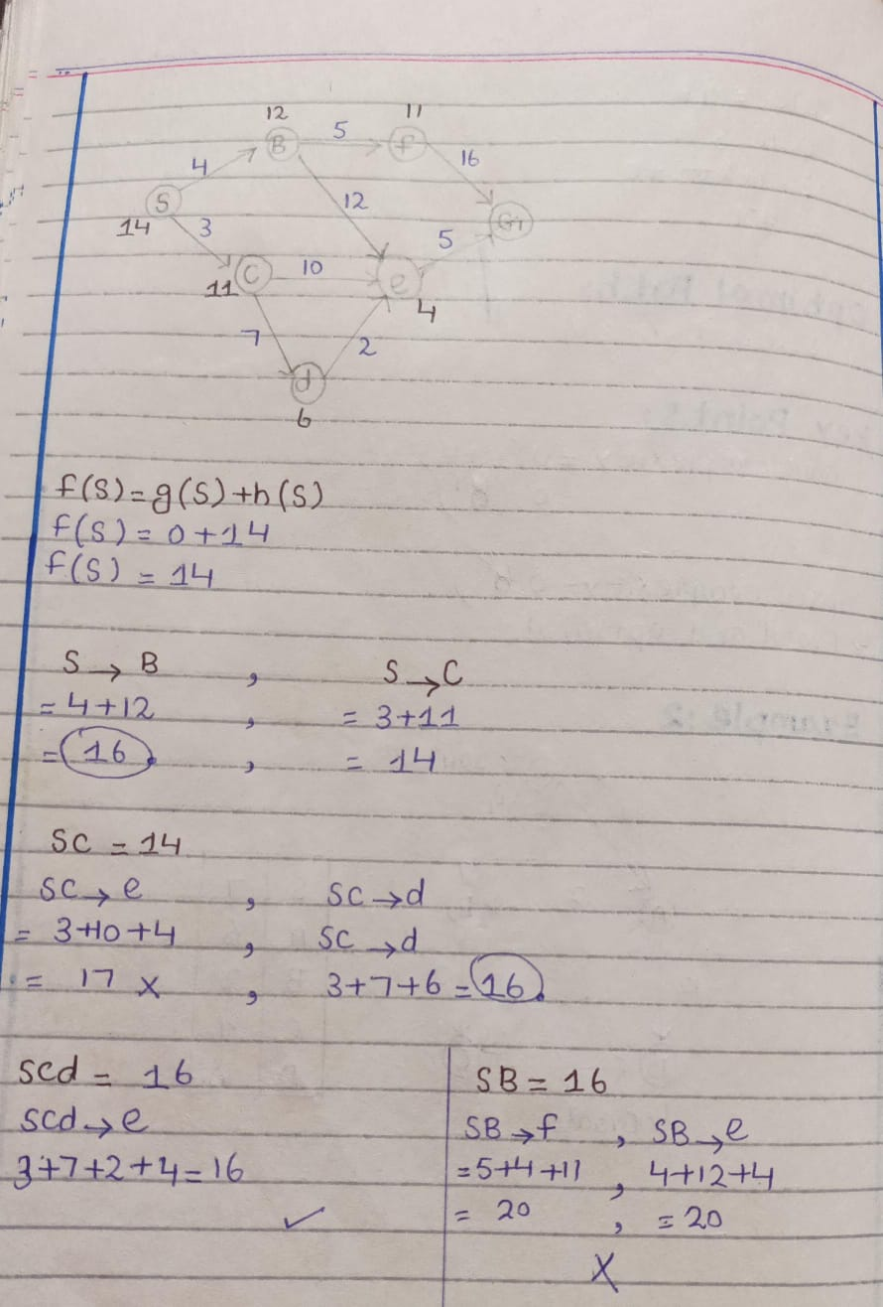
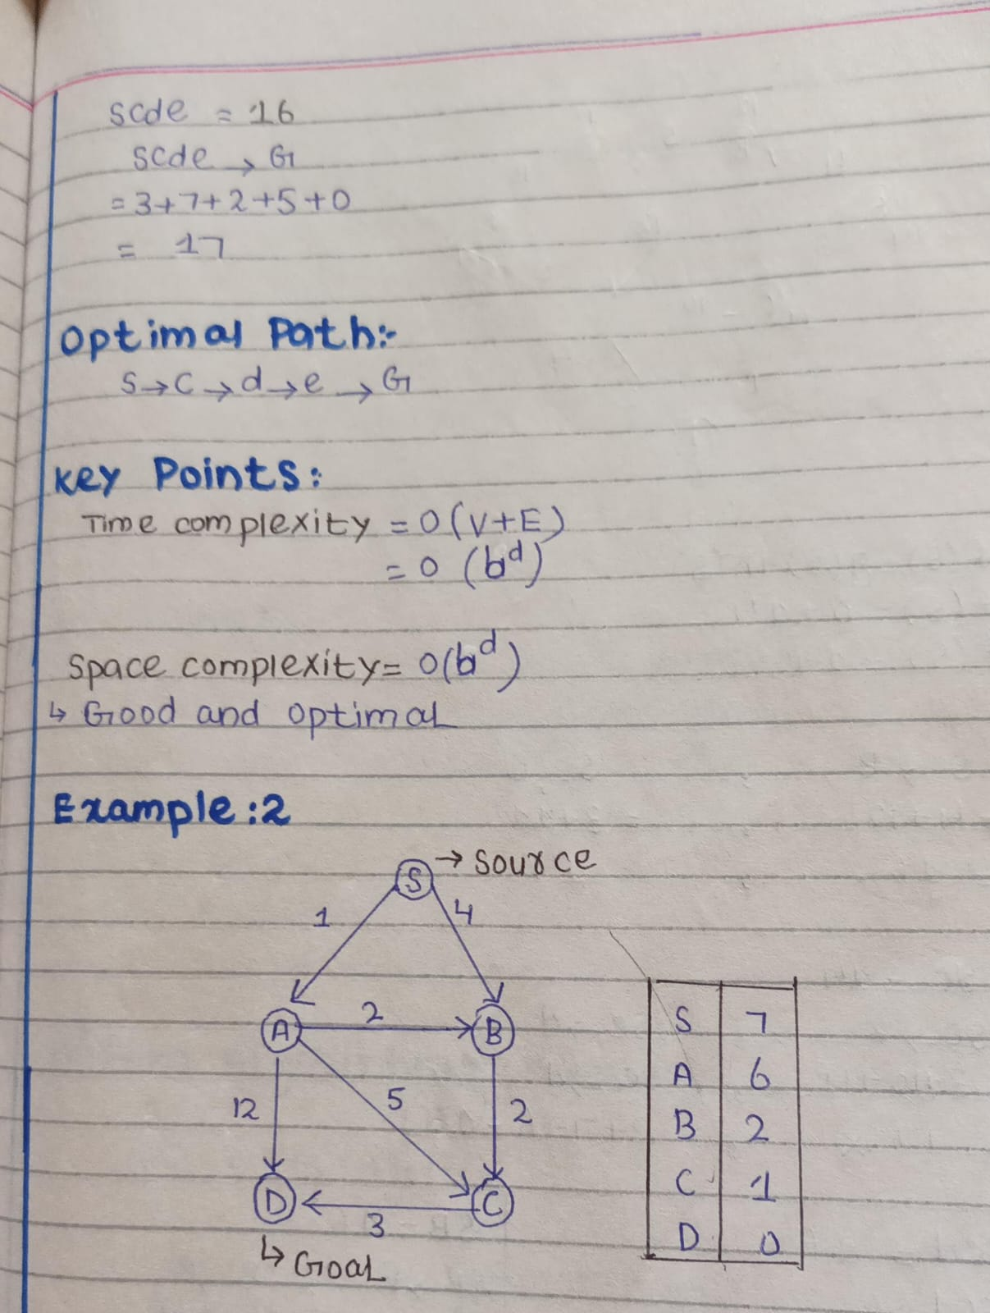

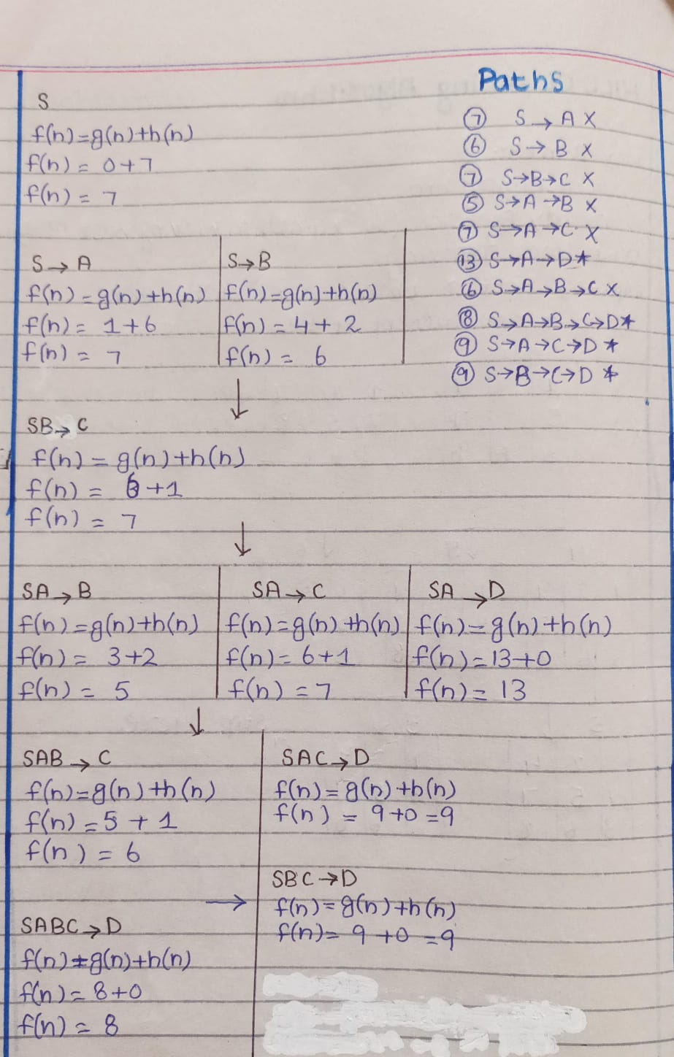
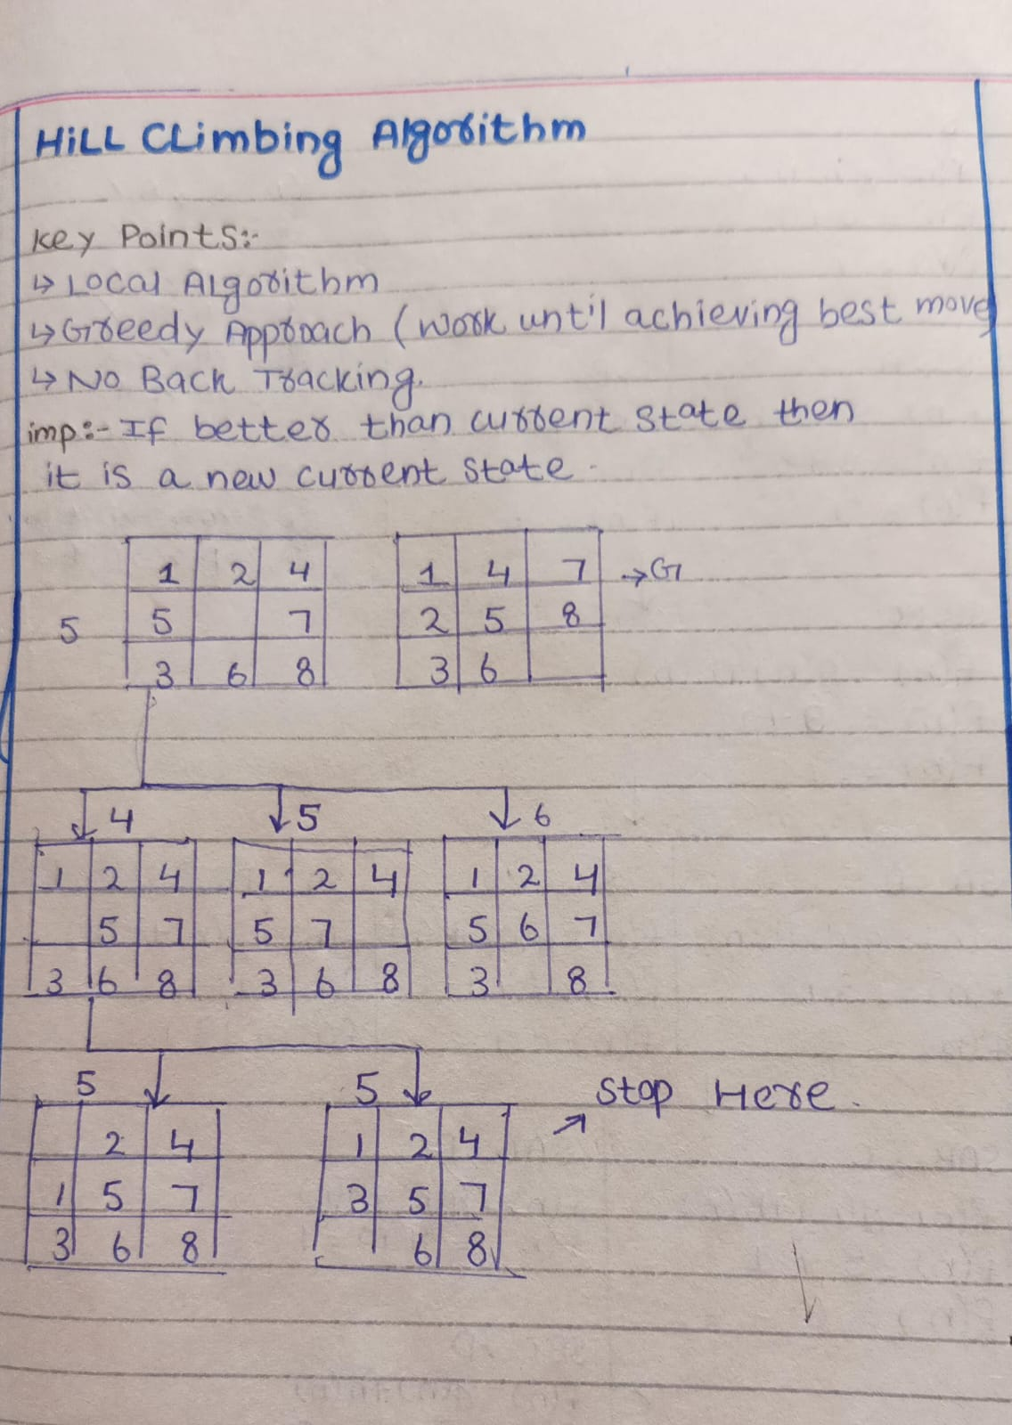
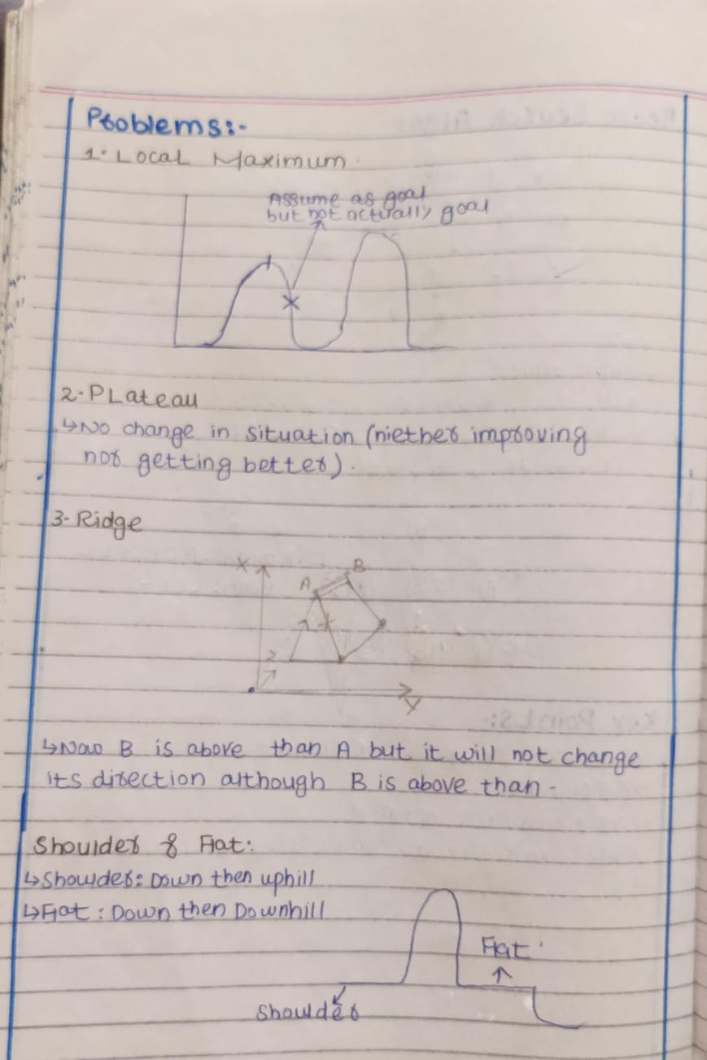
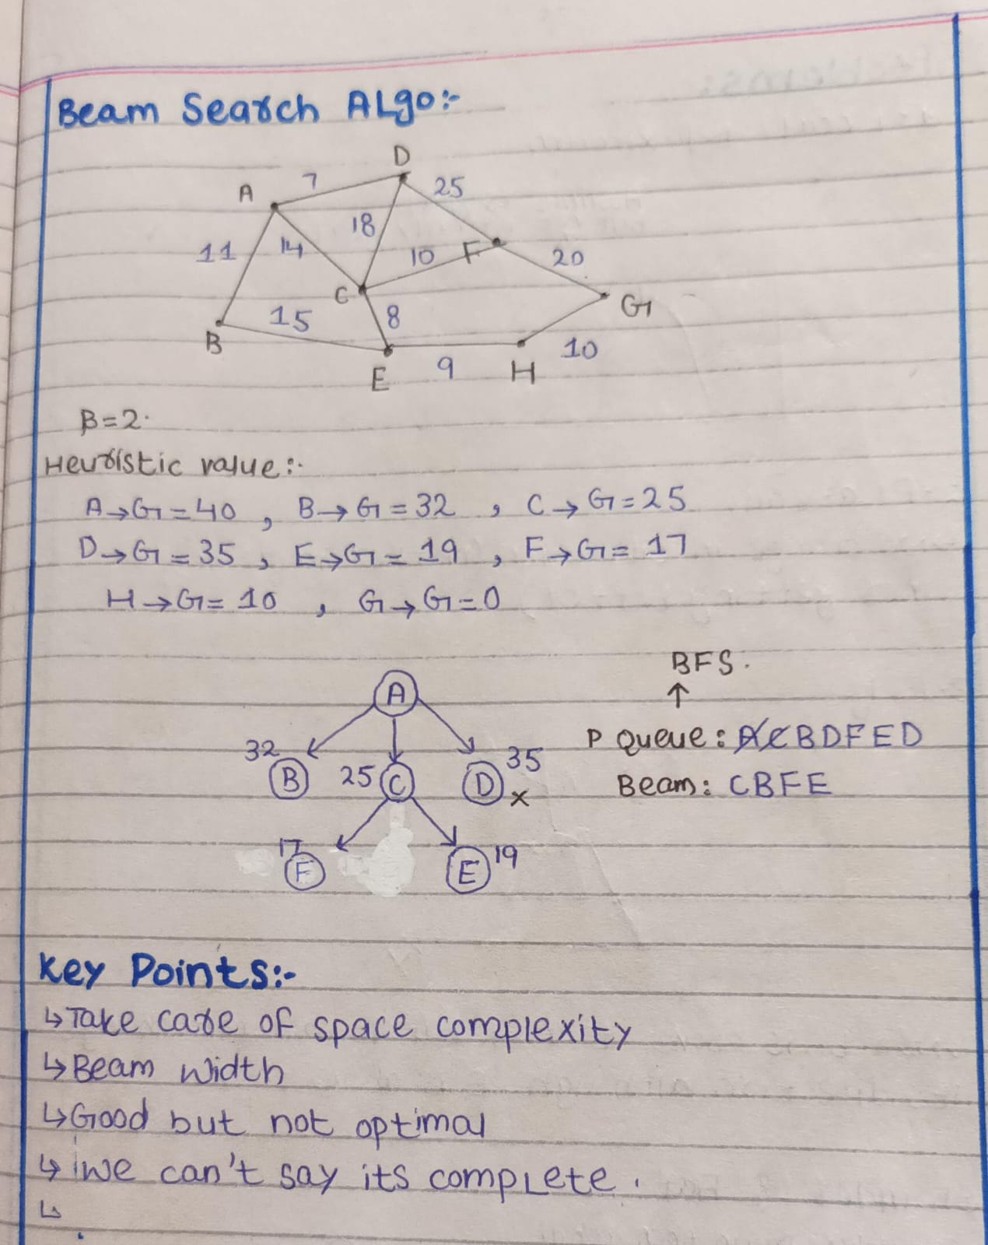

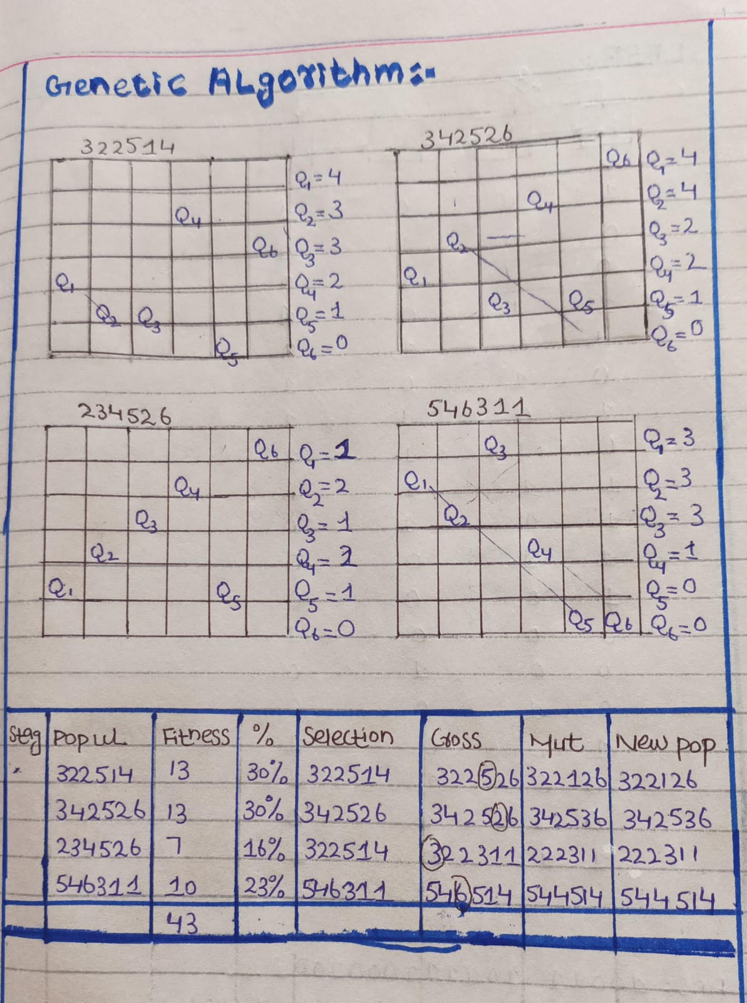
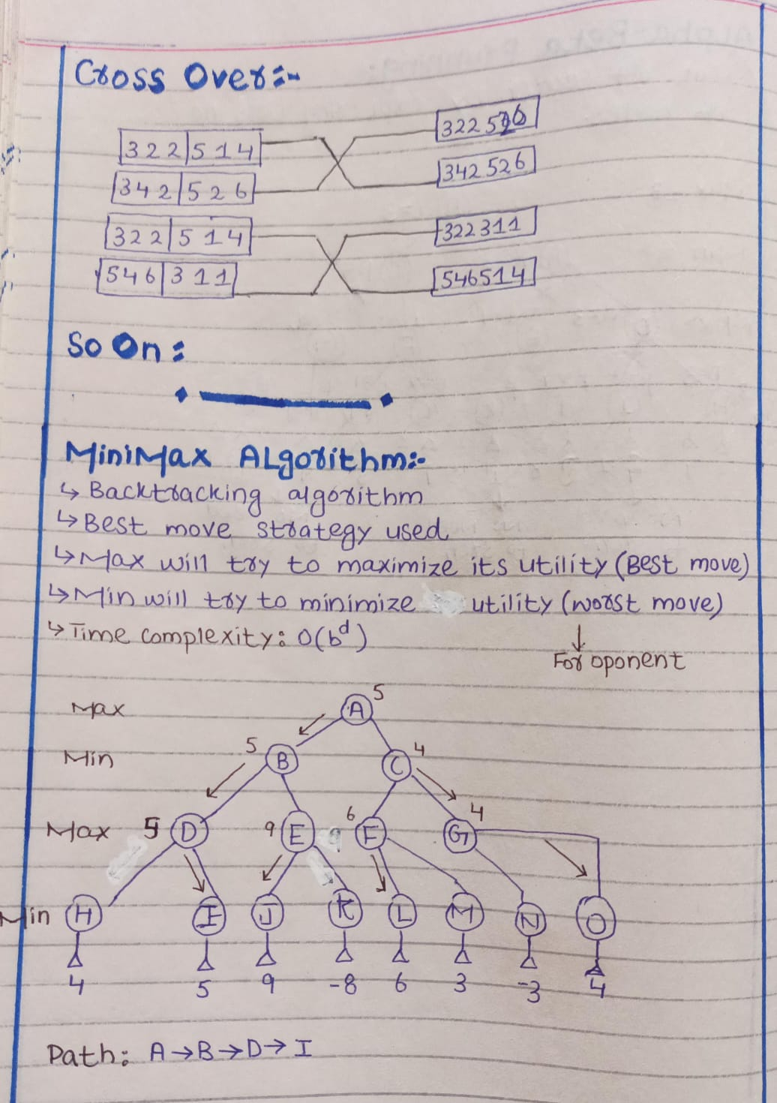
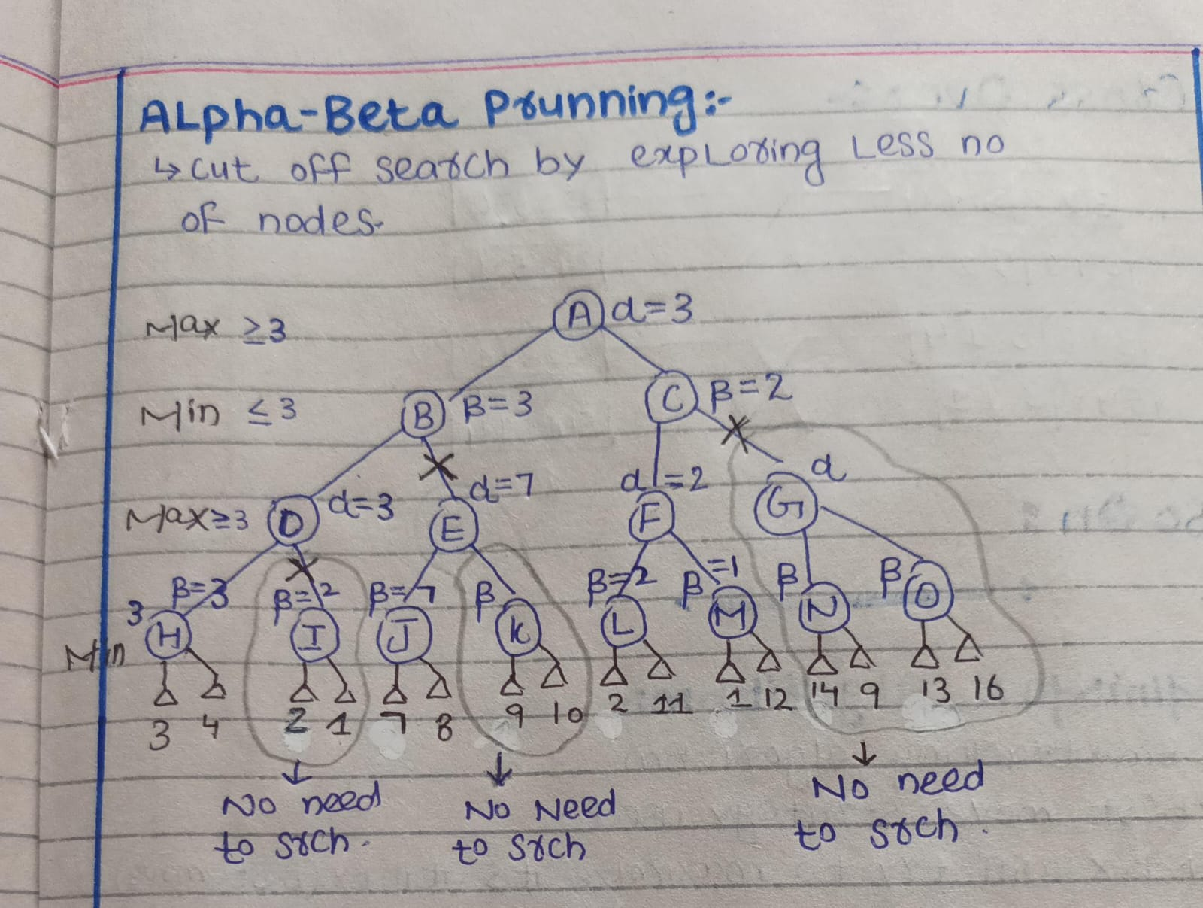
Constraint Satisfaction Problem
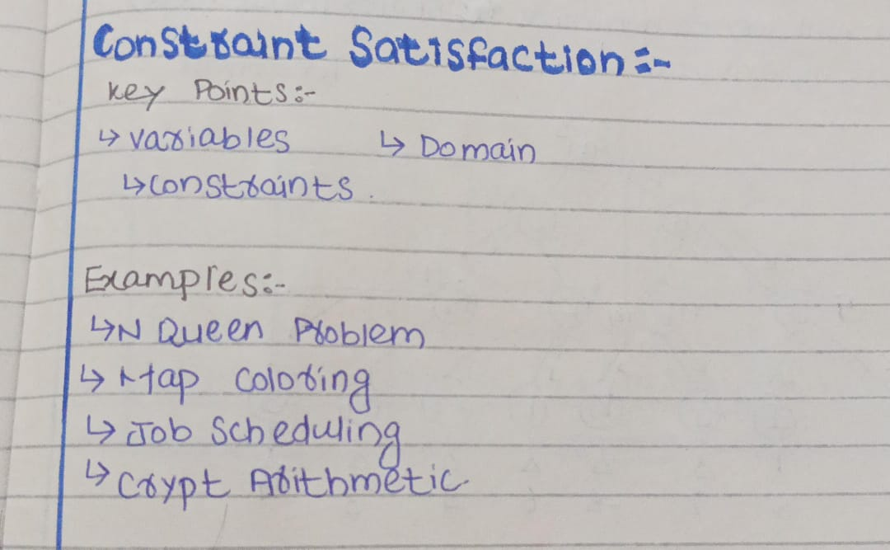

CSP:
CSP stands for Constraint Satisfaction Problem. It's a concept in Artificial Intelligence (AI) and Computer Science used to describe problems that can be solved by assigning values to variables while satisfying a number of constraints or conditions.
- Variables: Things you need to assign values to.
- Domains: Possible values each variable can take.
- Constraints: Rules that restrict which combinations of variable values are allowed
1. Complete Assignment
A complete assignment is when every variable in the CSP has been assigned a value while satisfying all constraints.
Example:
- Suppose we have three variables {X, Y, Z} and a domain {1, 2, 3}.
- If X = 1, Y = 2, Z = 3 and all constraints are satisfied, this is a complete assignment.
2. Partial Assignment
A partial assignment is when some variables have values, but others are still unassigned.
Example:
- Given {X, Y, Z}:
- X = 1, Y = 2, but Z is unassigned → this is a partial assignment.
- The search process continues until a complete assignment is found or backtracking is needed.
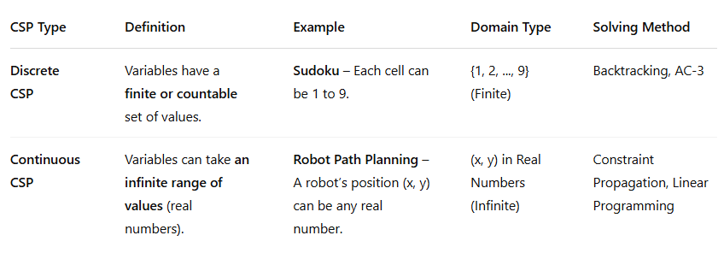

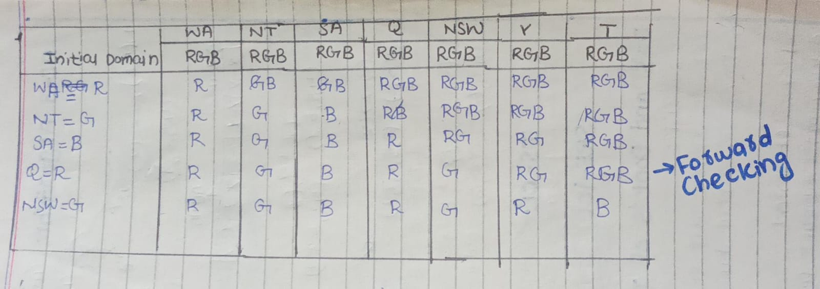

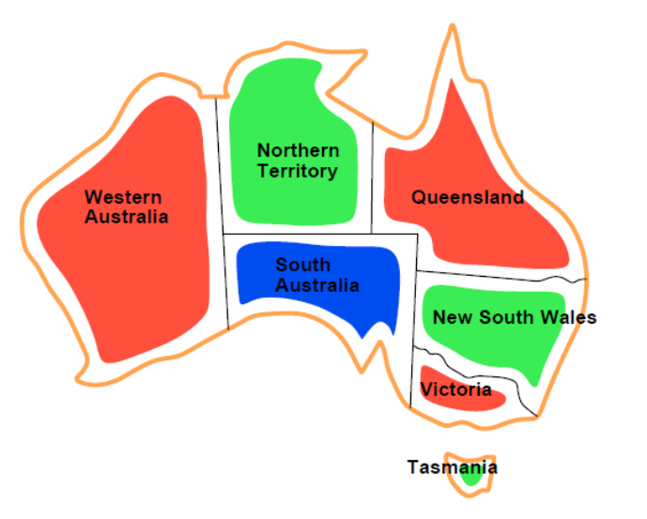
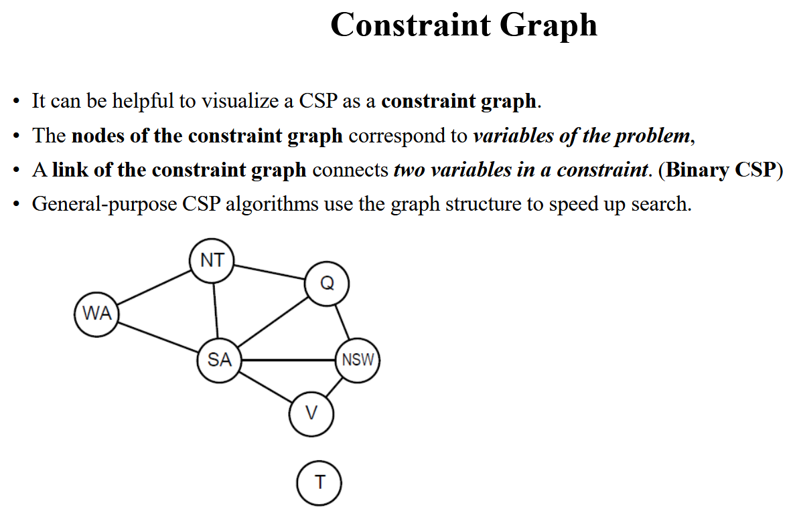
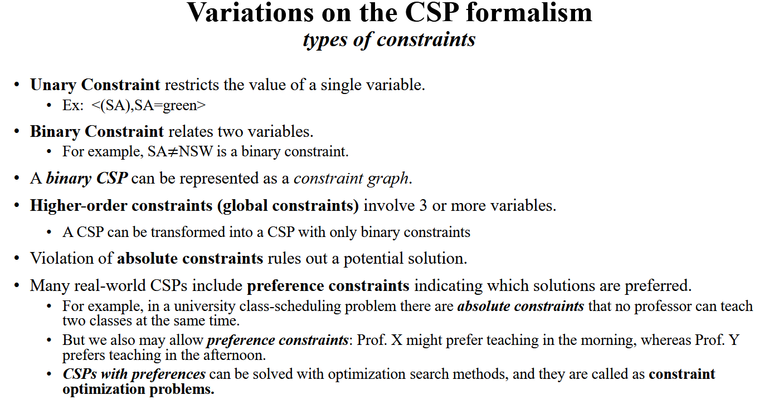

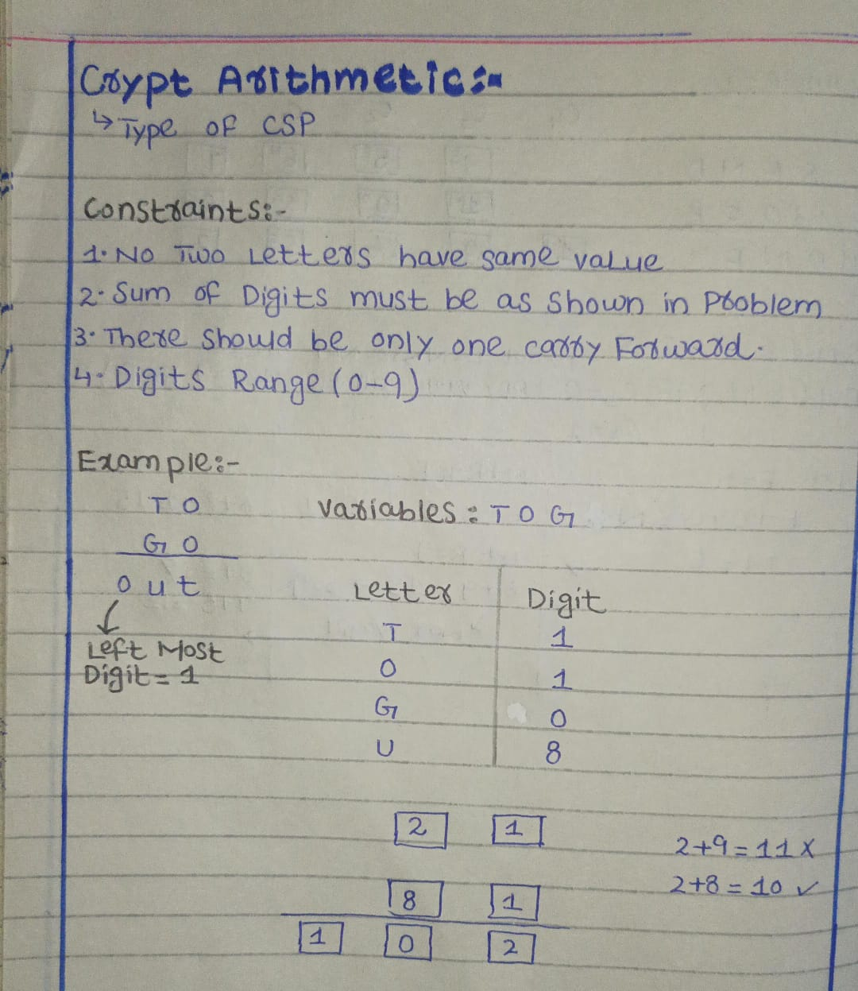
Cryptarithmetic

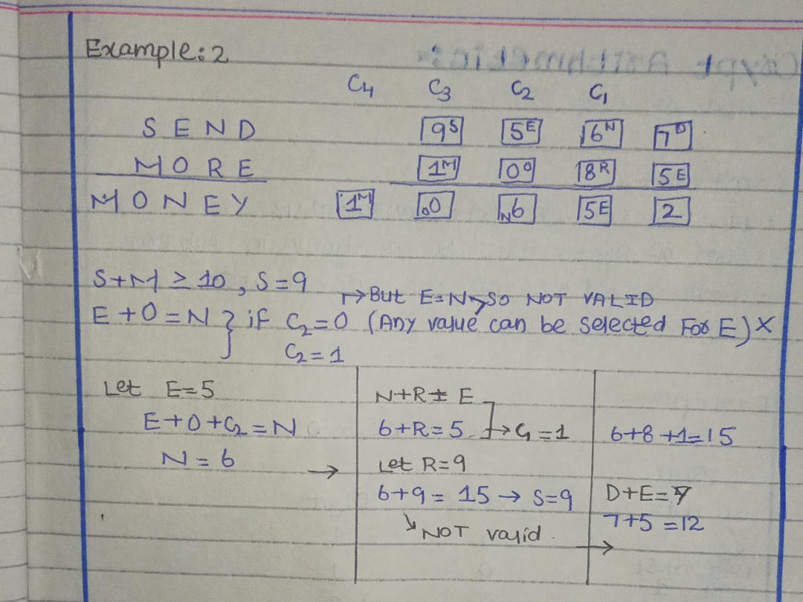

1. Arc Consistency (AC):
- It is a constraint propagation technique.
- Ensures that for every value in the domain of a variable X, there is some consistent value in the domain of another variable Y with which X shares a constraint.
- Example: If X ≠ Y, and X can be {1, 2}, Y can be {2}, then remove 2 from X's domain, so X becomes {1}.
- It can be applied before or during the search.
- AC-3 is a common algorithm for this.
2. Forward Checking:
- It is used during the backtracking search.
- After assigning a value to a variable, forward checking looks ahead and removes values from unassigned variables that conflict with the current assignment. It never ensures that those unassigned variables are conflicting with each other it just checks for its own.
- Helps avoid future conflicts early in the search
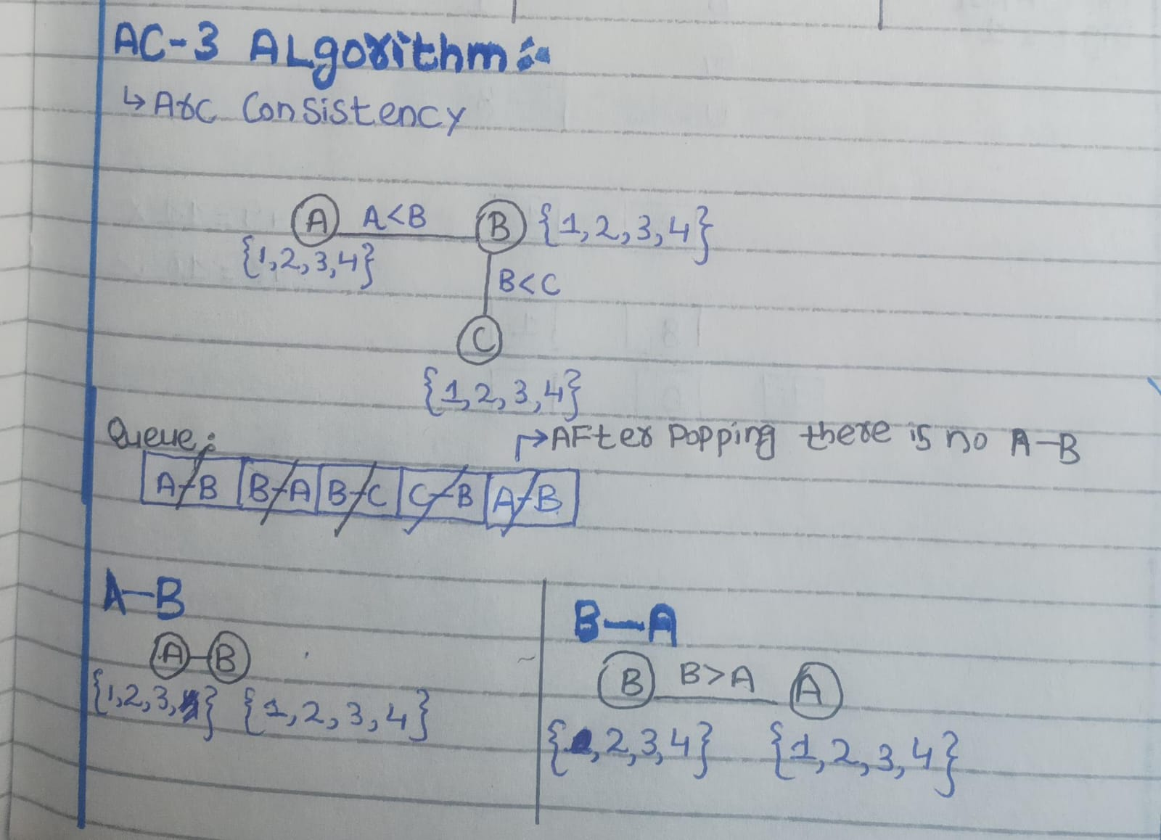
AC-3 Algorithm

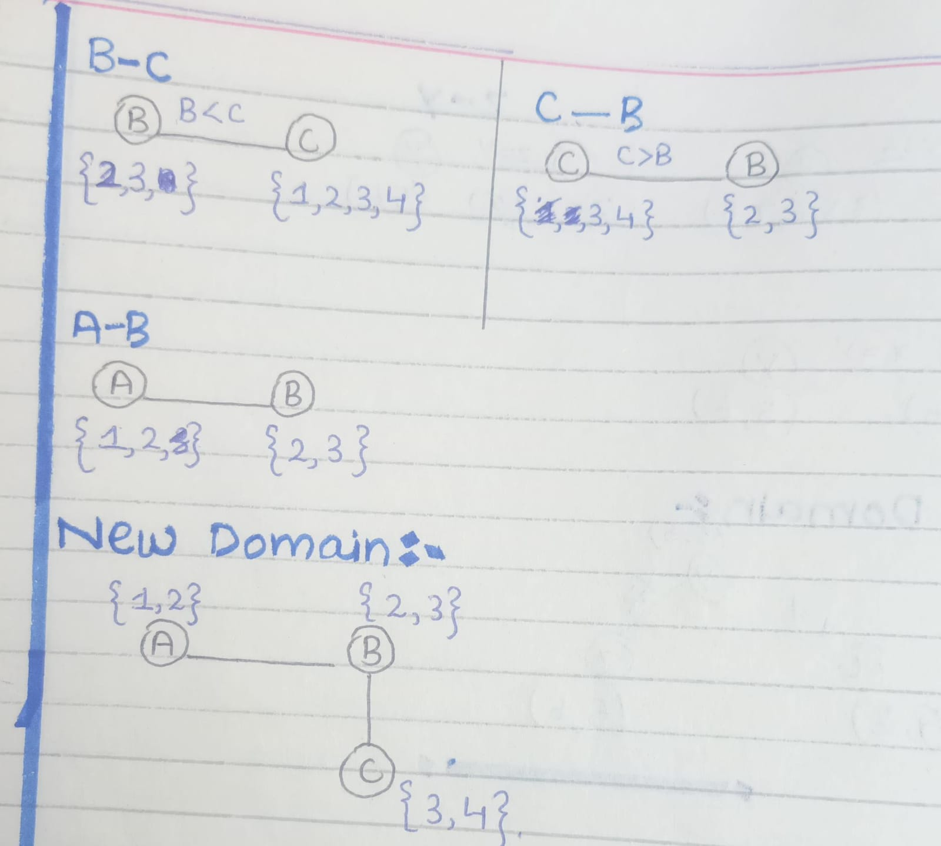

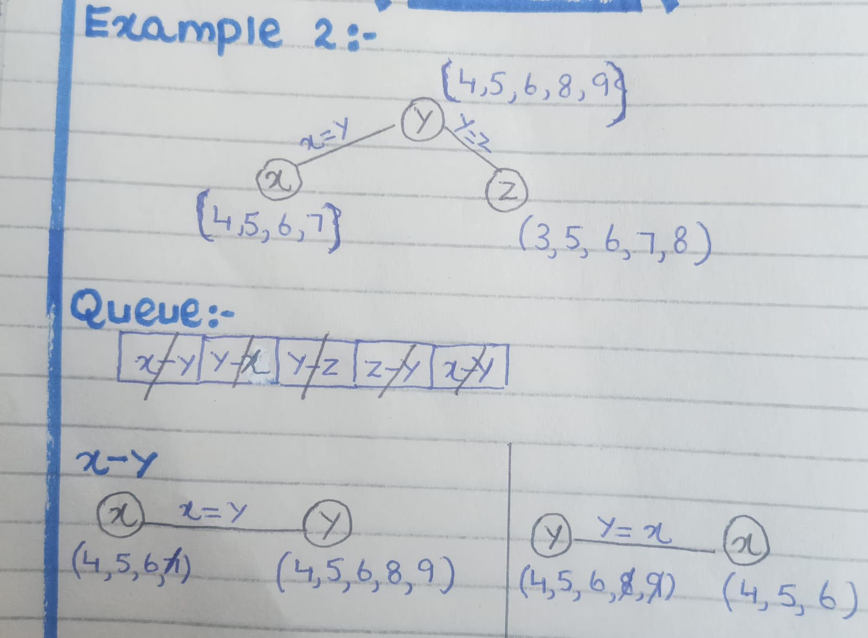

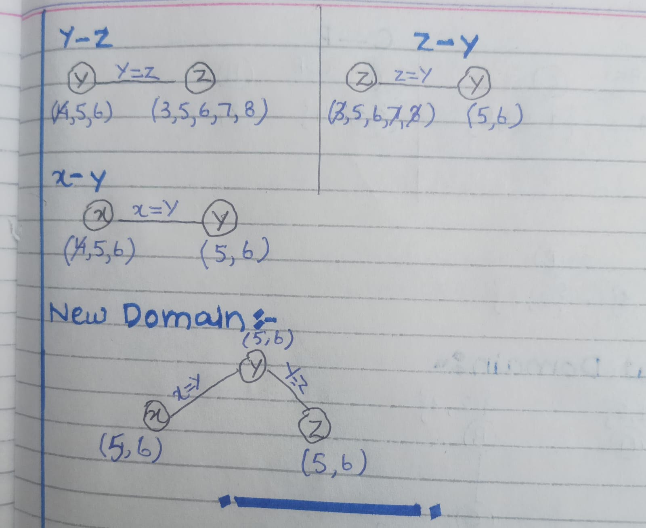

1. MRV (Minimum Remaining Values) – “Most constrained variable”
- What it does: Chooses the variable with the fewest legal values left.
- Why: Focuses on the variable that is most likely to fail first, so if there's a conflict, it’s found early.
- Used for: Variable selection
2. Degree Heuristic – “Most constraining variable”
- What it does: Chooses the variable that is involved in the most constraints with other unassigned variables.
- Why: Assigning this variable early reduces the complexity for others.
- Used for: Tiebreaker for MRV (when multiple variables have the same MRV)
3. LCV (Least Constraining Value) – “Leave options open”

- What it does: Picks the value that rules out the fewest choices for neighboring variables.
- Why: Helps keep more options available for future variables.
- Used for: Value selection
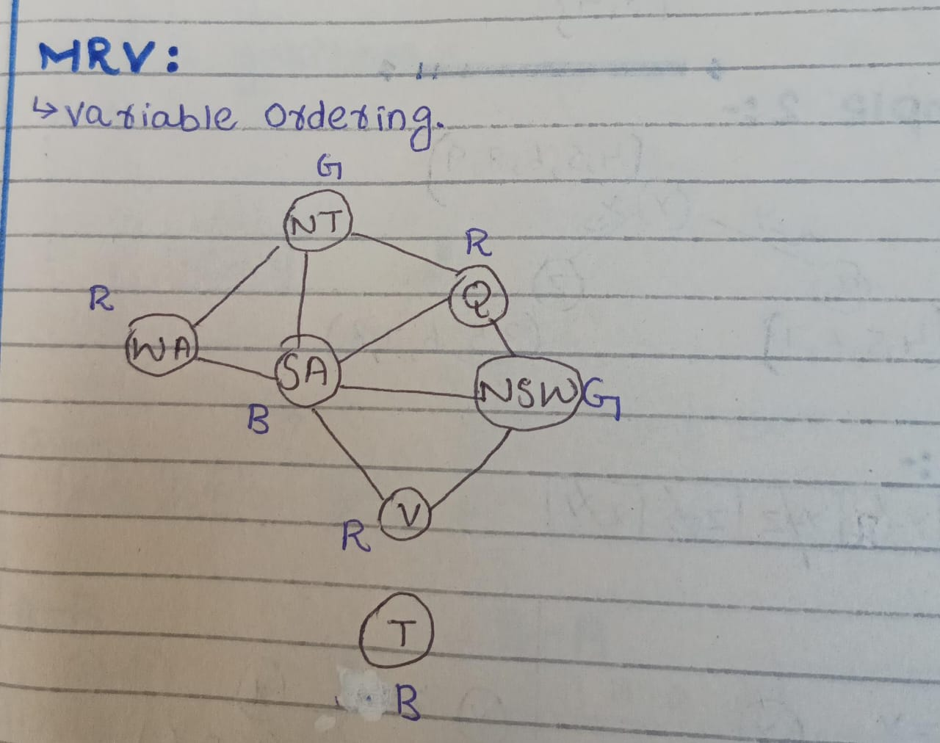
Most Remanning Value (MRV)

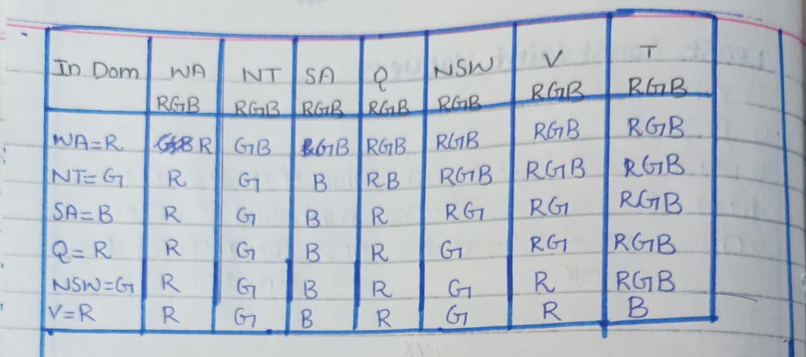
Degree Heuristic
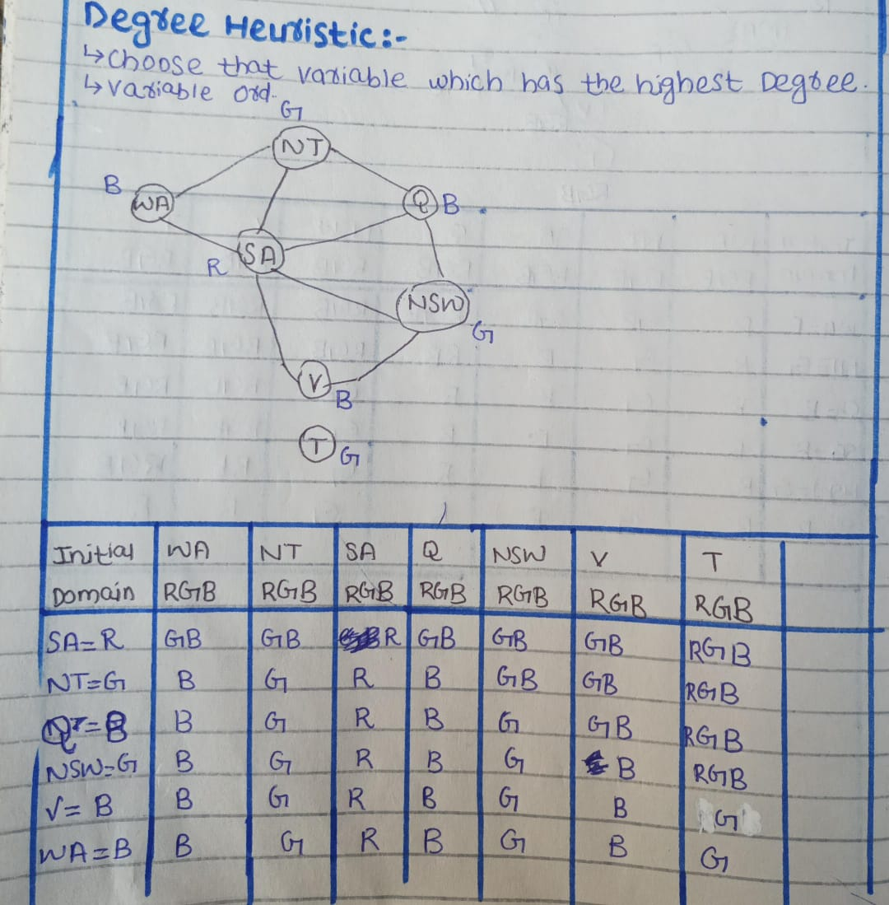
Least Constraint Value
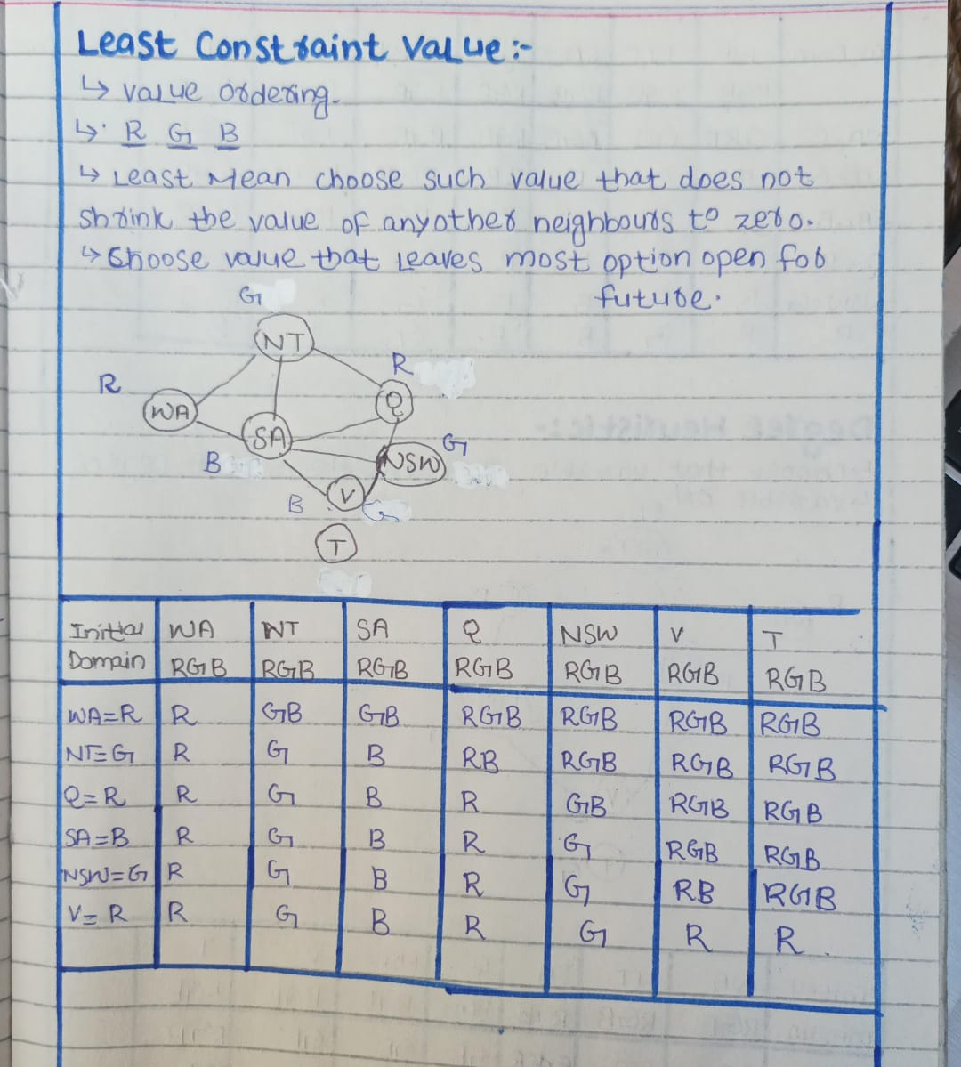

Knowledge Based Agents
A knowledge-based agent is a type of intelligent system that thinks and makes decisions using the knowledge it has about the world. It doesn't just act on fixed rules (like a reflex), but it reasons and draws conclusions using logic. Knowledge-based agents are supported by logic such as propositional logic or first-order predicate logic.
How It Works:
- Knowledge Base (KB):
The agent stores facts and rules in a place called a knowledge base. Think of it like a brain or a notebook full of facts.
- Inference Engine:
It uses logic (such as propositional logic or predicate logic) to figure out new facts from old ones. This process is called inference.
- Decision Making:
Based on the new facts, the agent decides what action to take.
Example:
Let’s say you have a smart home assistant.
Step 1: Knowledge Base has facts:
- Fact 1: If it is raining, then the windows should be closed.
- Fact 2: It is raining.
Step 2: Inference:
Using logic (like: If A → B, and A is true, then B is true),
The agent concludes: The windows should be closed.
Step 3: Action:
The agent tells the smart windows to close automatically.
Three Actions of Knowledge Base
TELL (what it sees)
The agent TELLs the knowledge base what it has just observed or sensed from the environment. It adds new facts to the knowledge base.
Example
"It is raining" → the agent sees this and adds it to its memory.
ASK (what to do next)
The agent ASKs the knowledge base what action it should take. It uses reasoning and logic to think about:
- What is happening now
- What could happen next
- Which action is best
Example:
Agent thinks:
"If it is raining, should I stay home or go out?"
TELL (what it will do)
The agent TELLs the knowledge base what action it has chosen to perform, and then it executes (does) that action.
Example:
"It is raining → I will stay home"
The agent updates its knowledge and stays home.
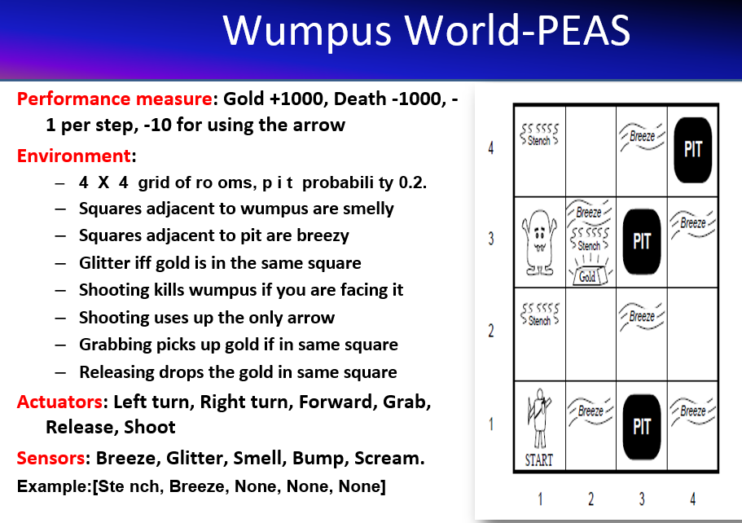

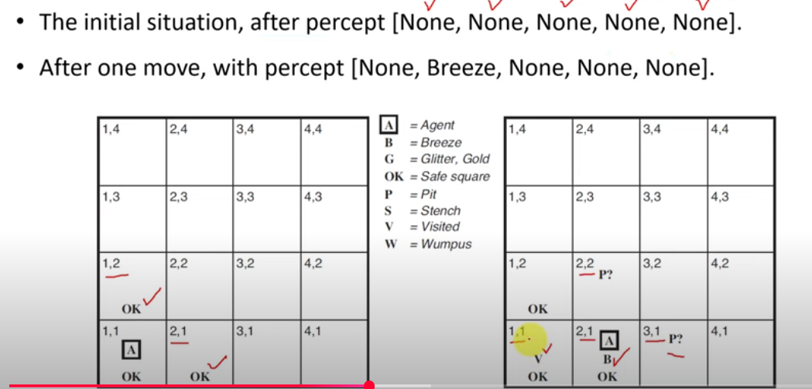

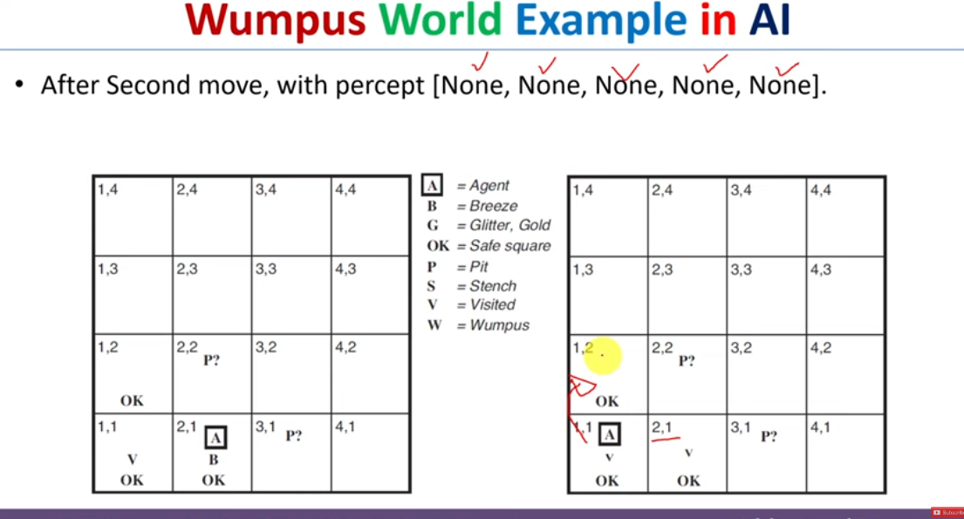

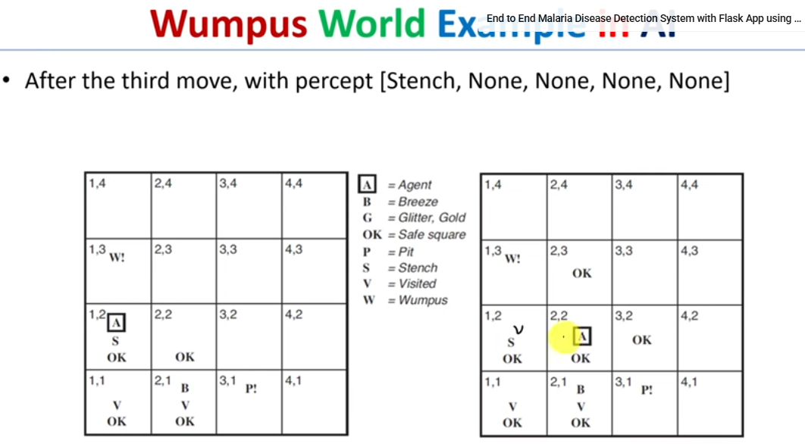

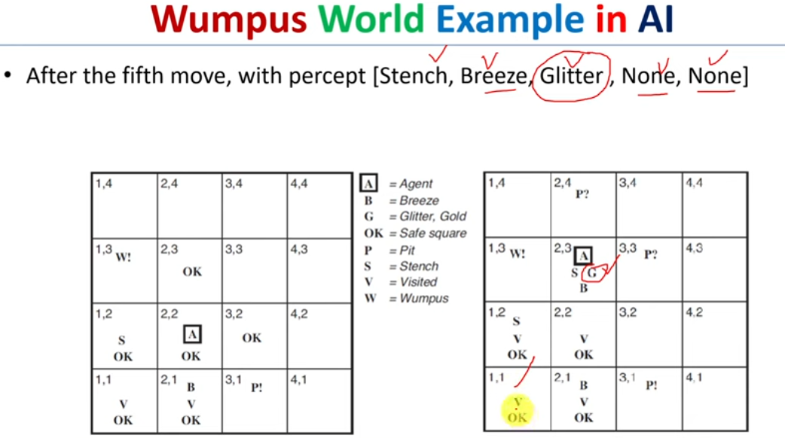
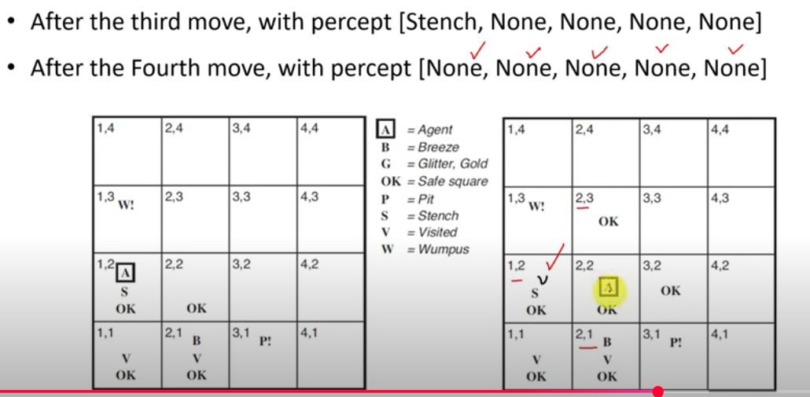

Wumpus World
- Fully Observable? No - only local perception
- Deterministic? Yes -outcomes exactly specified
- Episodic? No - sequential at the level of actions
- Static? Yes -Wumpus and Pits do not move
- Discrete? Yes
- Single-agent? Yes
Logic
Logic is a formal way to represent knowledge so that a system (like an agent) can make conclusions or reason about it.
A logical language has two parts:
1. Syntax – the rules for writing correct sentences.
- For example, x + 2 ≥ y is written correctly.
- But x² + y > is not – it’s an incorrect sentence.
2. Semantics – the meaning of a sentence.
- It tells us when the sentence is true or false.
- Example: Arithmetic
Sentence: x + 2 ≥ y
- This means: "x plus 2 is greater than or equal to y"
Whether it's true or false depends on the values of x and y:
- If x = 7 and y = 1 → 7 + 2 = 9, and 9 ≥ 1 → True
- If x = 0 and y = 6 → 0 + 2 = 2, and 2 ≥ 6 → False

Model
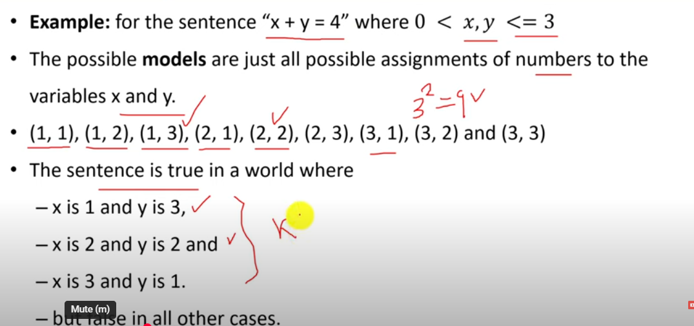
Models are ways of imagining how the world could be — they show what is true or false. Think of a model as a possible world or a situation. In that world, some statements are true, and some are not.
Logical Entailment (other names: Logical Consequence or Logical Implication)
Logical Entailment between sentences means that a sentence follows logically from another sentence. In mathematical notation, 𝜶 ⊨ 𝜷
The formal definition of entailment:
𝜶 logically entails 𝜷 𝜶 ⊨ 𝜷 if and only if, 𝜷 is true in all worlds where 𝜶 is true
𝜶 ⊨ 𝜷 if and only if M(𝜶) ⊆ M(𝜷).
- M(α) means: the set of all models (possible situations or "worlds") where α is true.
- M(β) is the set of models where β is true.
Example
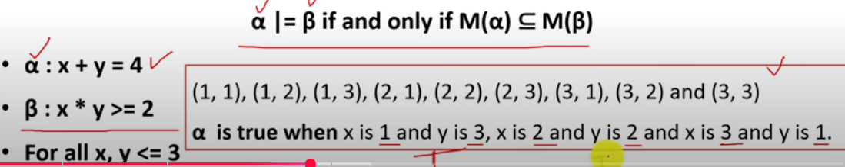
Logical Entailment in Wumpus World
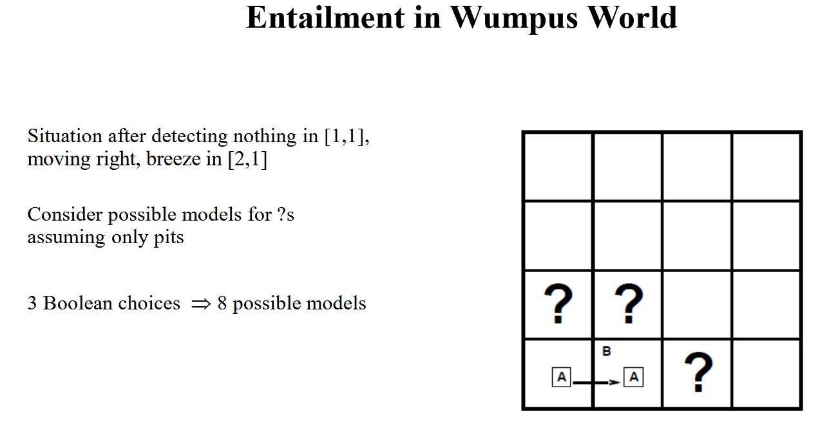

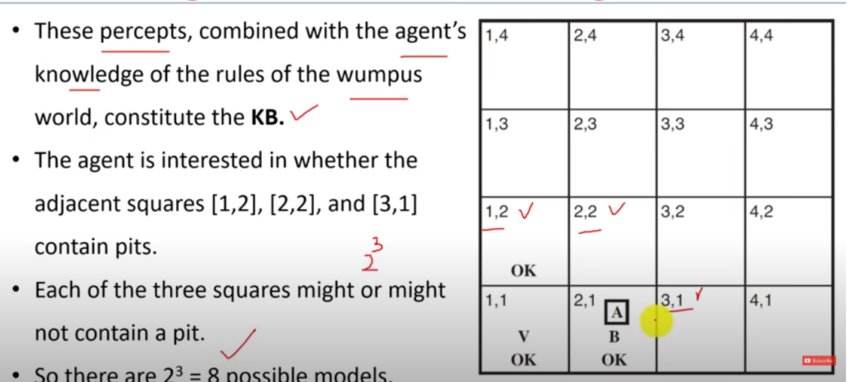
Check whether Alpha 1 is true statement or not

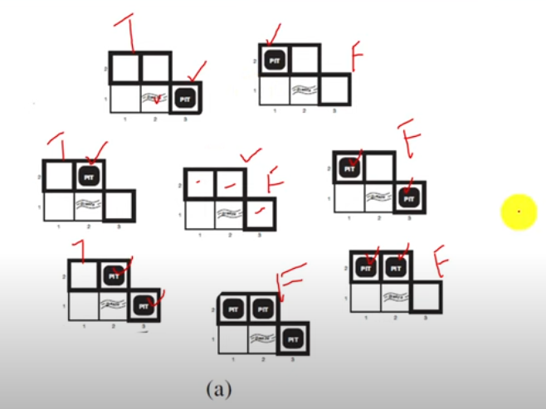

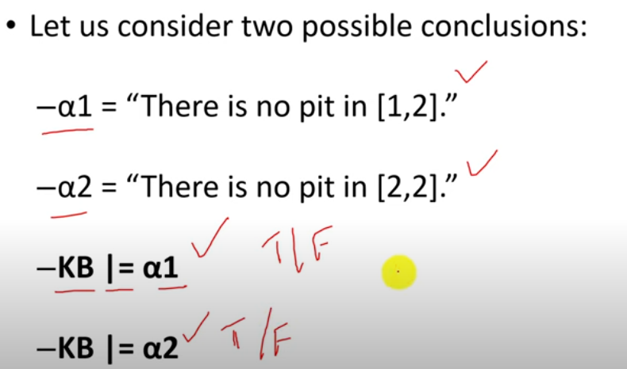
Queries We Want to Answers?
Check whether Alpha-1 is a true statement or not
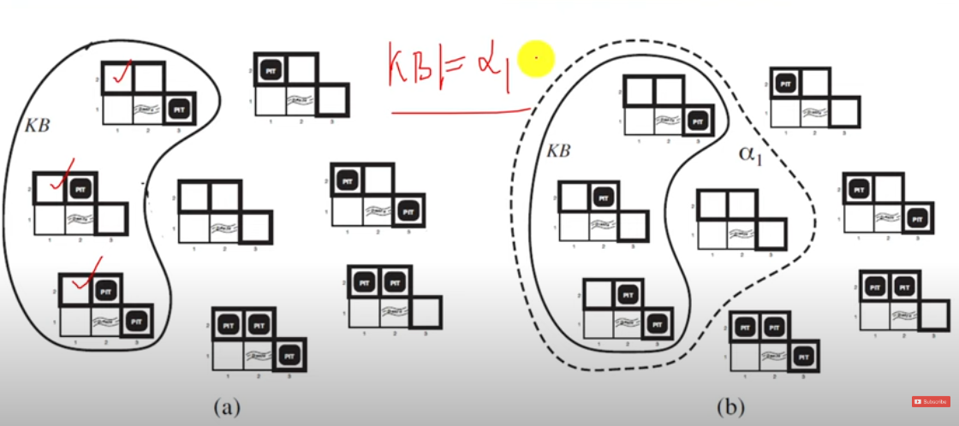
KB logically Entails Alpha 1 so Alpha 1 is a true statement
Check whether Alpha 2 is a true statement or not
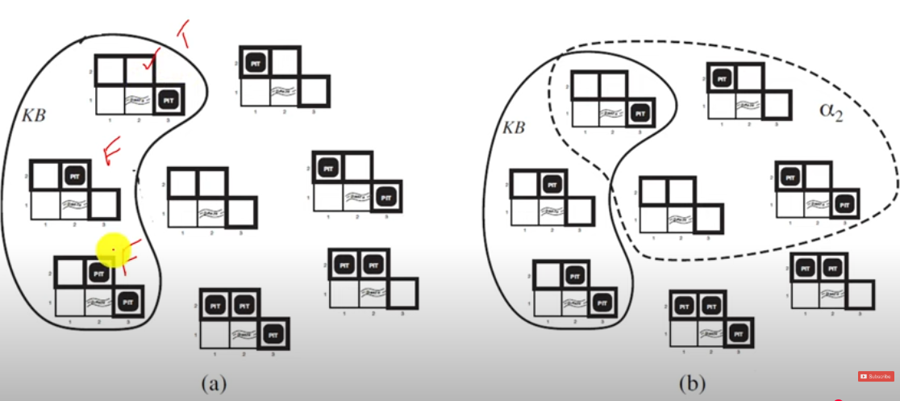
KB does not logically entail Alpha 2 so Alpha 2 is false statement
Model Checking
What is Model Checking?
In the Wumpus World, we use logical rules to figure out what is true based on what we know.
This process is called entailment — we try to conclude something new from the information we already have (our knowledge base, or KB).
What does Model Checking do?
Try out all possible situations (called models) and check if your guess (called α) is always true in those situations where the known facts (KB) are true.
Inference Proofs
Inference means using logic to prove new things from what we already know.
What does this mean?
If an inference method (like a proof technique) helps us figure out α (a new fact) from our KB (known facts), we write:
KB ⊢i α
This means:
“Using method i, we can prove α from KB.”
How does it work?
- Start with known facts (called premises)
- Use rules of logic (called inference rules)
- Step-by-step, create new facts from the old ones
- Keep doing this until you reach α (your goal)
Also remember:
- Some facts are called axioms — always true in all situations.
- Every new fact must come from applying a valid rule to previous ones.
Example
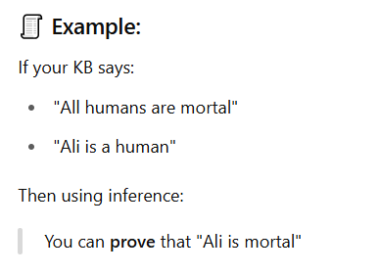
Inference Types
1. Soundness – "No Wrong Answers"
An inference method is sound if: Whatever it proves is always correct.
In simple words:
If the algorithm says "α is true", then α really is true based on your knowledge.
Meaning:
It doesn’t give you false conclusions.
Example:
If your KB says "All birds can fly" and "Sparrow is a bird",
A sound inference method will correctly say "Sparrow can fly".
2. Completeness – "Finds All Right Answers"
An inference method is complete if: It can find every true thing that logically follows from your KB.
Meaning:
If something is logically true, the method will eventually prove it.
Example:
If from your KB, "Ali is human" and "All humans are mortal",
And "Ali is mortal" is logically true,
Then a complete method will be able to prove "Ali is mortal".
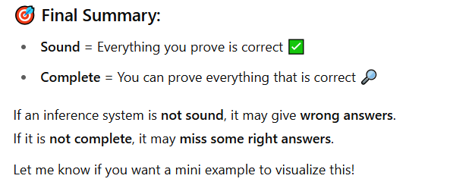
What is Propositional Logic?
Propositional Logic (also called statement logic) is a branch of logic where we use simple, clear statements (called propositions) that are either true or false — nothing in between. Each proposition is represented by a letter (like P, Q, R). We then use logical connectives (AND, OR, NOT, etc.) to build more complex statements.
Syntax
- Tells us how to write valid statements using symbols and connectives.
- Example: P ∧ Q is a valid sentence.
Semantics
- Tells us what the statement means — whether it's true or false in a given situation (model).
- Truth is checked using truth tables.
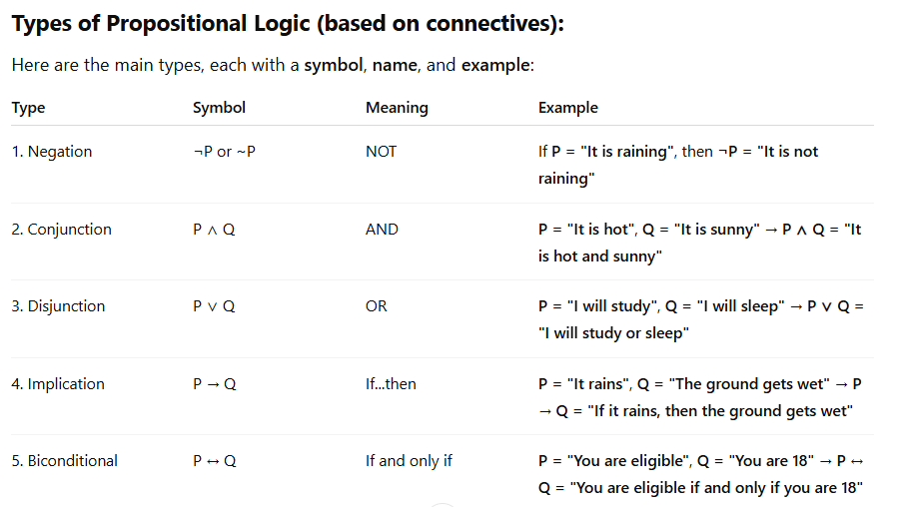
Atomic Preposition
An atomic proposition (or simple proposition) is a single, indivisible statement that is either true or false, but not both. It doesn’t use any logical connectives (like AND, OR, NOT).
Compound Proposition
A compound proposition is a complex statement made by combining two or more atomic propositions using logical connectives like:
- AND ( ∧ )
- OR ( ∨ )
- NOT ( ¬ )
- IMPLIES ( → )
- IF AND ONLY IF ( ↔ )
Note: There are two proposition symbols with fixed meanings (constants): True is the always-true proposition and False is the always-false proposition.
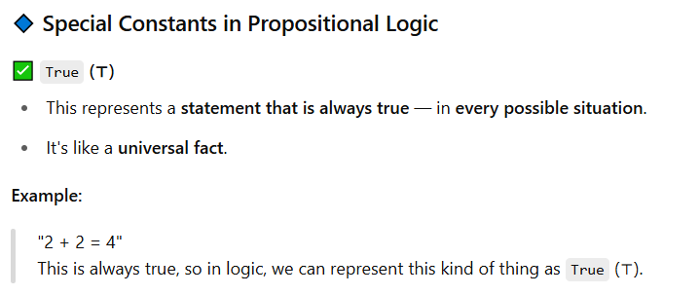

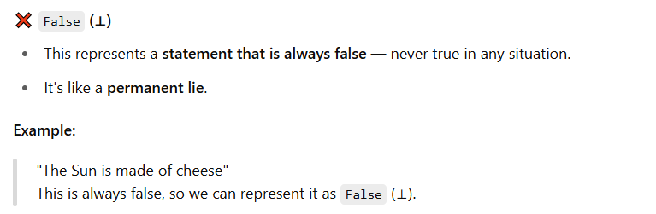
What is Logical Equivalence?
Two statements (propositions) are logically equivalent if they are always true or false in the same situations — that means they have the same truth value in every possible case.
Example:
Let’s take these two statements:
- P → Q (If P then Q)
- ¬P ∨ Q (Not P or Q)
These may look different, but they are logically equivalent — they are true and false under the exact same conditions.
So, we write:
P → Q ≡ ¬P ∨ Q
This "≡" means logically equivalent.

Tautologoy and contradiction
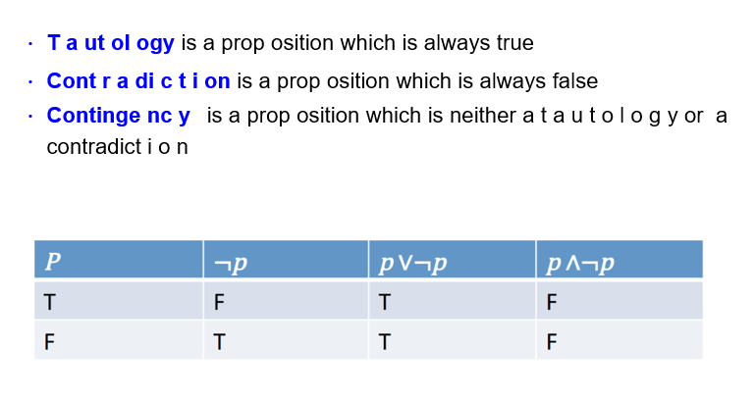
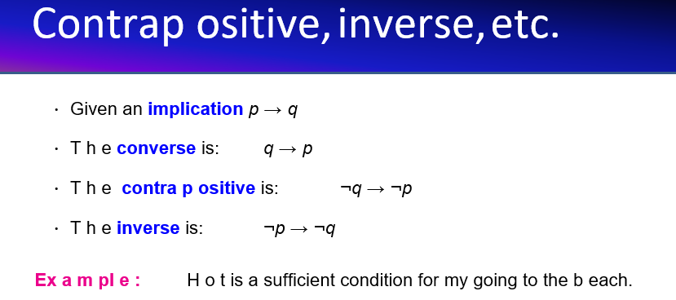
Premises, Predicates and Conclusion
Premise
A premise is a starting statement or assumption in logic that you accept as true. It's used to build toward a conclusion.
Example:
- "If it rains, the ground gets wet." (Premise 1)
- "It is raining." (Premise 2)
Predicate
A predicate is a logical expression that contains a variable. It becomes a full statement (true/false) when you substitute the variable with a specific value.
Example:
- Predicate: P(x): "x is a student"
- If x = John → P(John): "John is a student" → becomes a statement
Conclusion
A conclusion is the logical result that follows from the premises using a valid rule of inference.
Example (from earlier):
- Premise 1: If it rains, the ground gets wet.
- Premise 2: It is raining.
- Conclusion: The ground gets wet.
Rules of Inferences
Modus Ponen
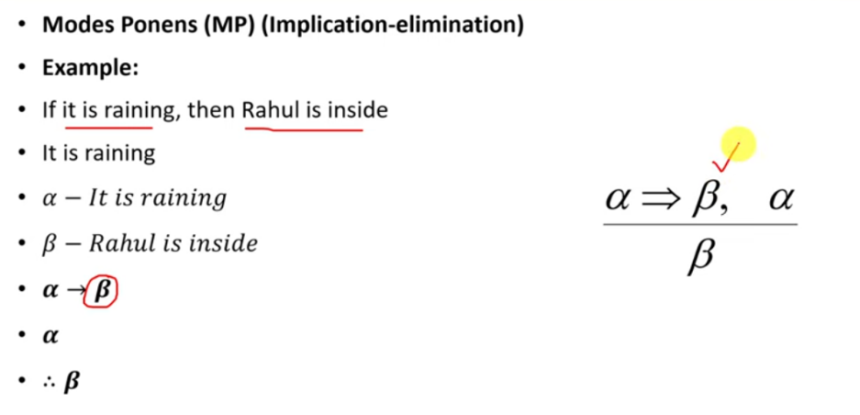

Modus Tollen
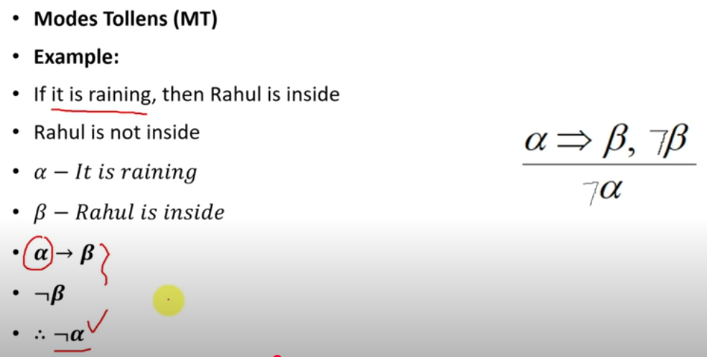
And Elimination \ Simplification
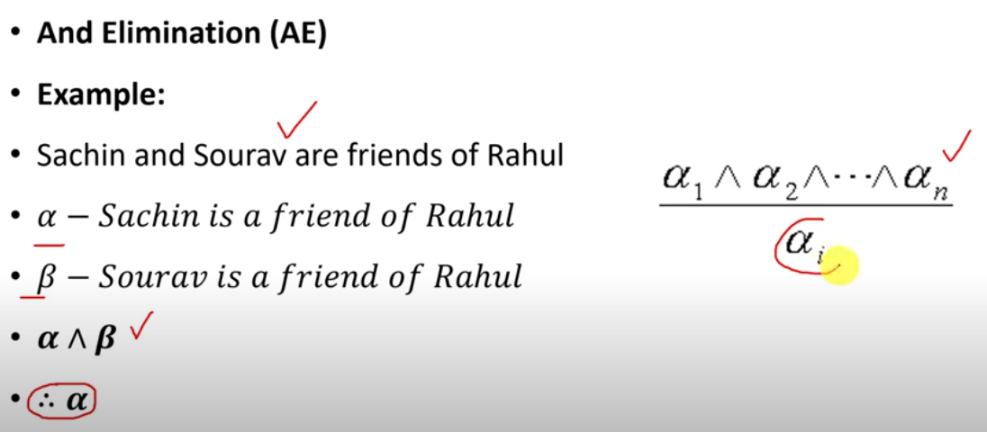
Note: - beta can be the conclusion too

And Introduction \ Conjunction
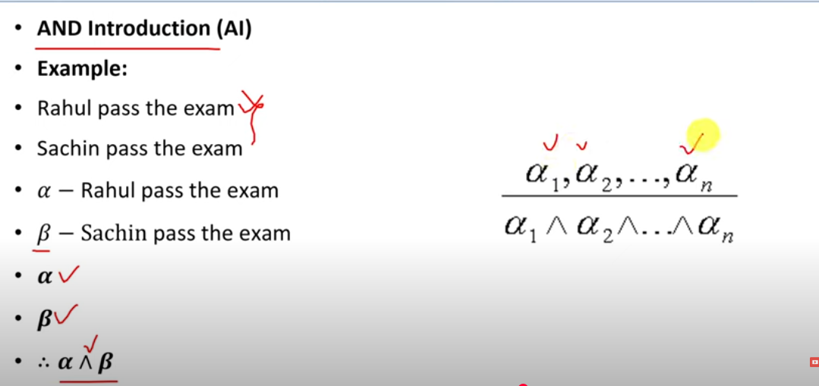
Addition \ OR Introduction
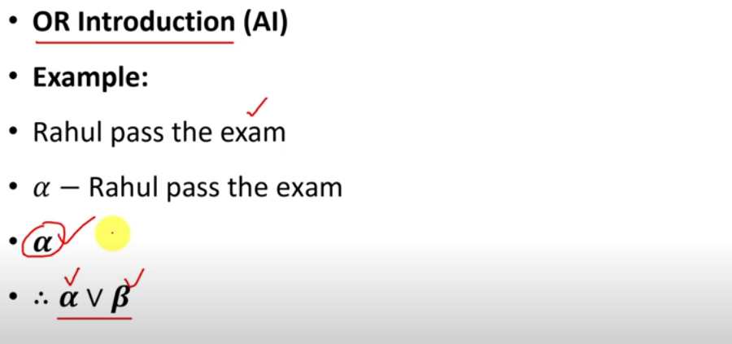
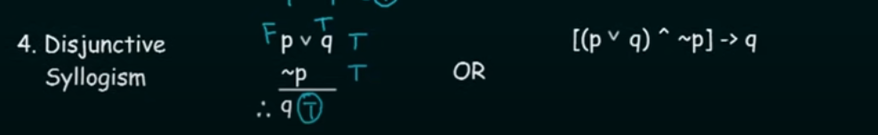
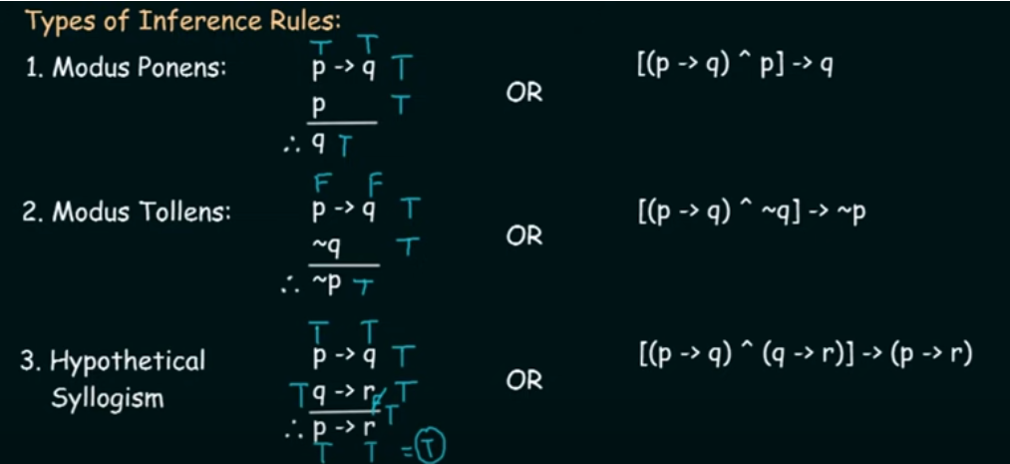
Summary of all rules

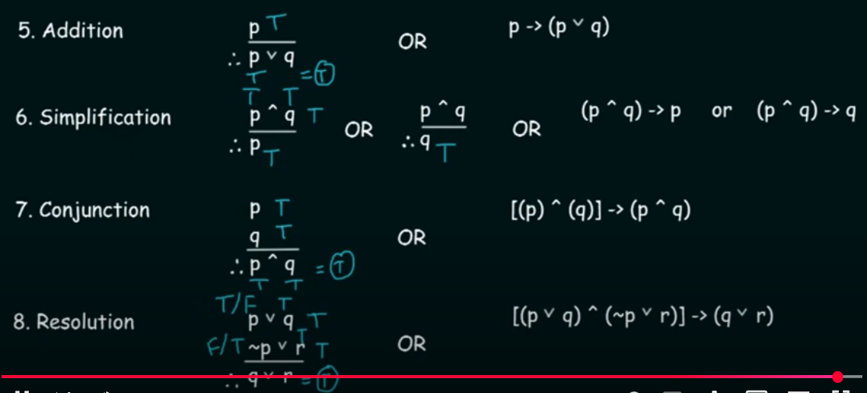
Propositional Logic: Wumpus world sentences
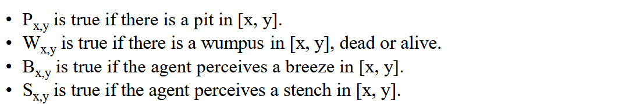
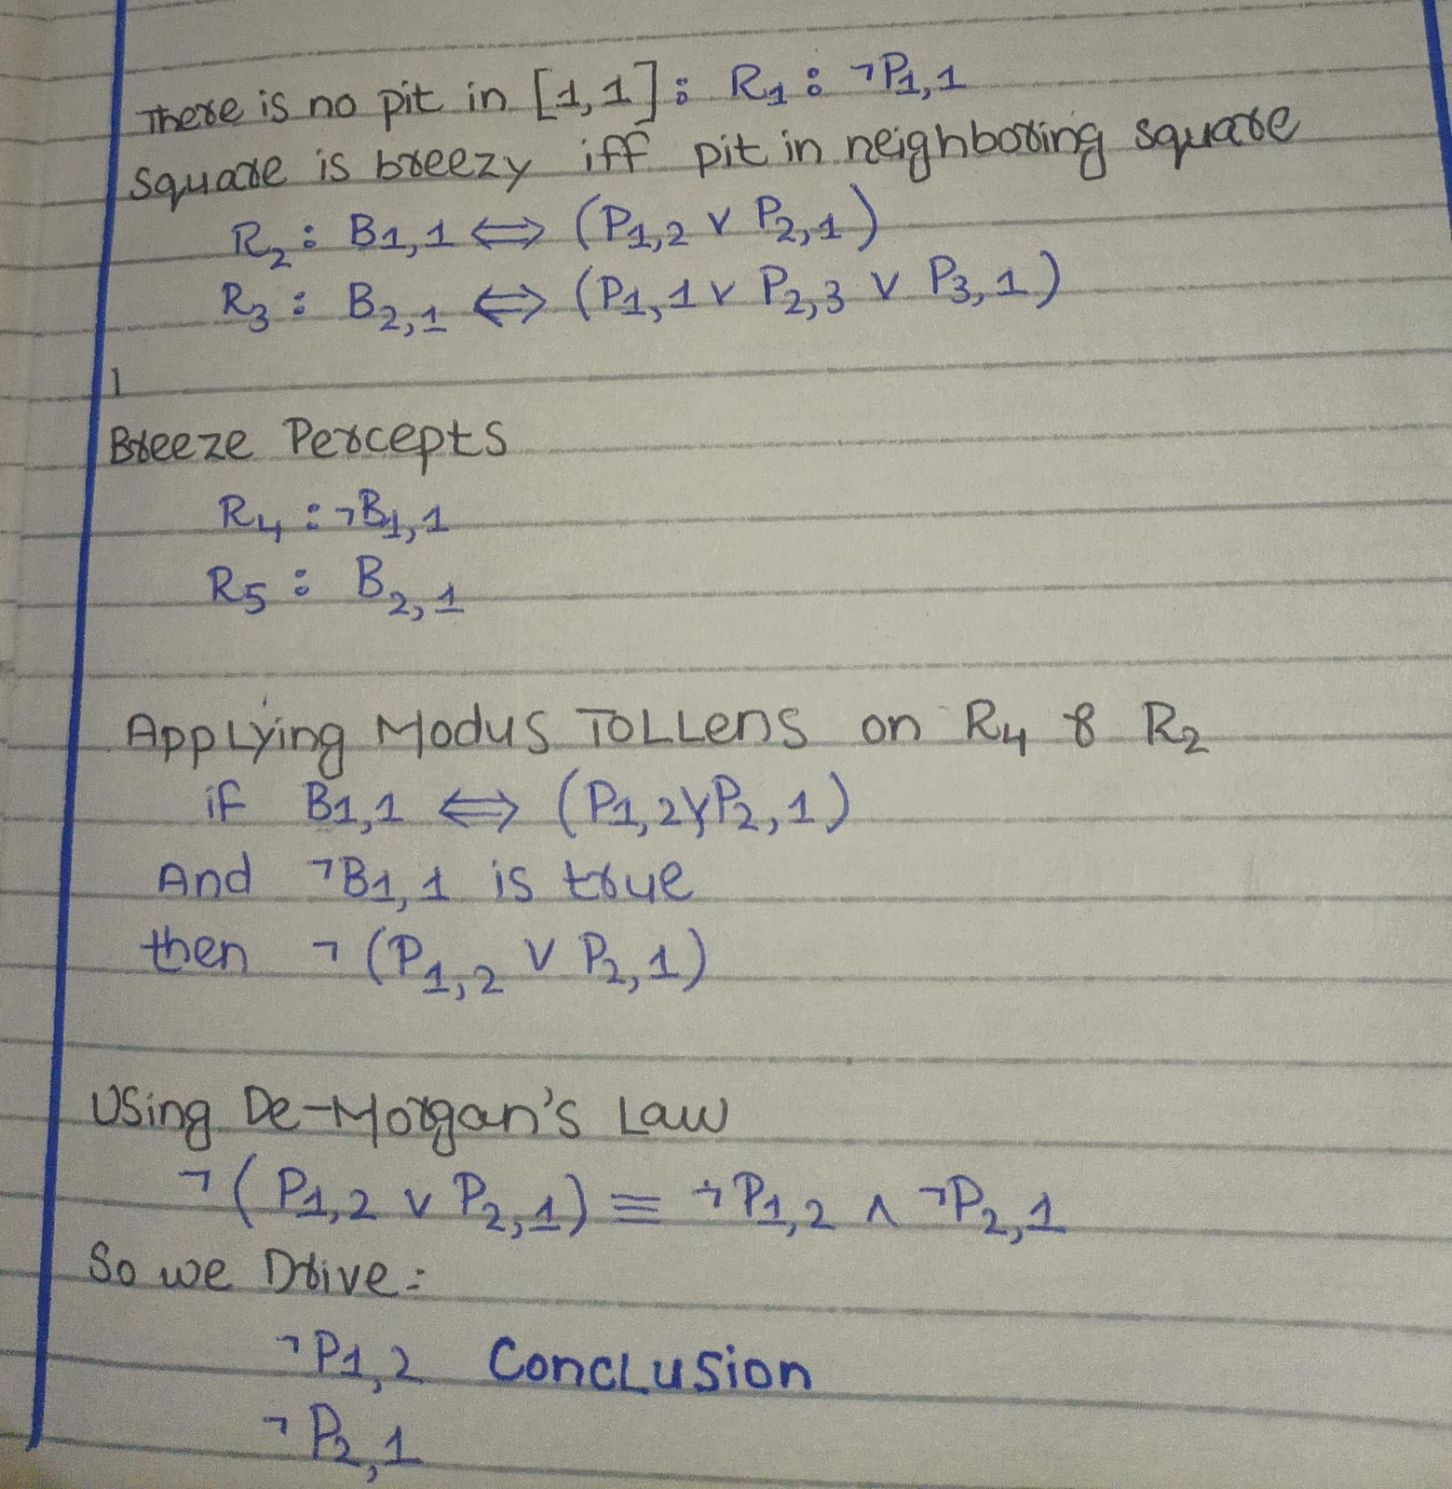

Propositional Logic – Inference by Enumeration of Models
Goal:
We want to check if a statement (like ¬P₁,₂) must be true based on our knowledge base (KB).
In logic terms, this means:
Is α (¬P₁,₂) logically entailed by KB?
(i.e., Does KB ⊨ α?)
What is “Inference by Enumeration of Models”?
It’s a method to check if a conclusion is correct by doing the following:
- List all possible models (ways to assign true/false to all variables like P₁,₁, B₁,₁, etc.).
- For each model:
- Check if the KB is true in that model.
- If yes, then see if α (like ¬P₁,₂) is also true in that same model.
- If α is true in every model where KB is true, then KB ⊨ α (inference is valid).
Inference by Enumeration of Models algorithm is sound and complete.
- If KB and α contain n symbols in all, then there are 2^{n} models.
- Thus, the time complexity of the algorithm is O(2^{n}).

What does sound mean?
An inference algorithm is sound if every conclusion it derives is logically correct — that is, it only derives statements that are actually true given the knowledge base.
- In other words: If the algorithm says "α is true," then α really is true in all models where the knowledge base (KB) is true.
- It never derives false conclusions.
What does complete mean?
An inference algorithm is complete if it can derive every conclusion that is logically entailed by the knowledge base — it never misses a true conclusion.
- In other words: If α is true in every model where KB is true (KB entails α), then the algorithm will find and derive α.
Putting it together for Enumeration of Models:
- The Enumeration of Models algorithm checks all possible models (interpretations of the symbols) to see if α is true whenever KB is true.
- It's sound because it only returns that α is entailed if it holds in all models that satisfy KB.
- It's complete because it considers all models, so if α is indeed entailed, it will find this by examining every relevant model.
- The downside is that because it checks all 2^n models (where n is the number of symbols), its time complexity is O(2^n) — which can be very expensive!
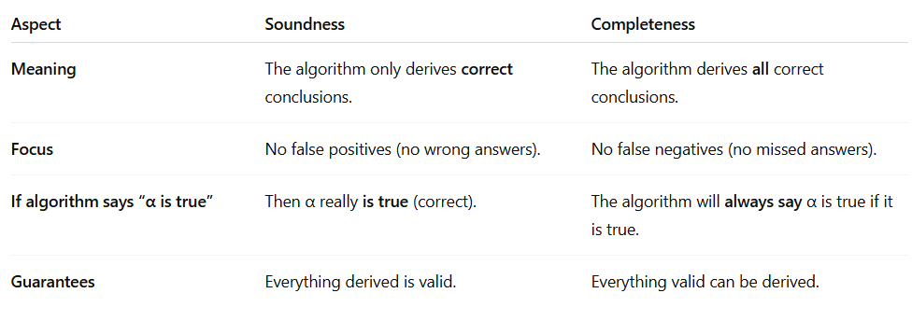
Enumration Checking of there is no pit in 1,2
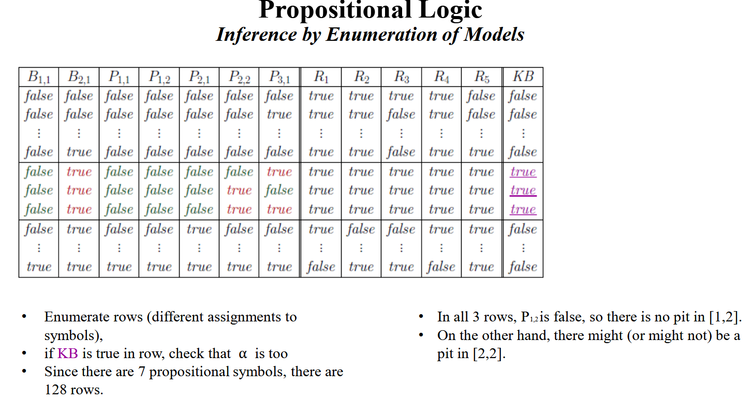

Logical Equelance
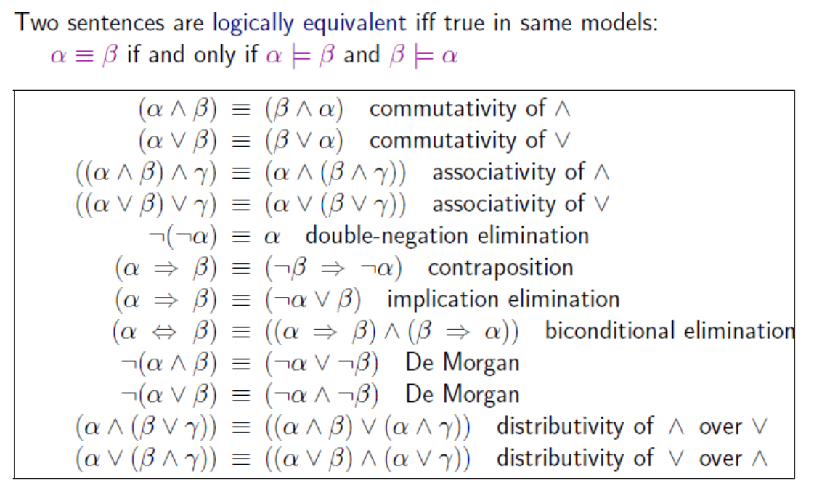
Validity and Satisfiability
1.Validity (True in all models):
A sentence is valid if it is always true, no matter how you assign truth values to its symbols.
Example:
A ∨ ¬A
- No matter what truth value you give to A (true or false), this is always true.
- If A = true, then A ∨ ¬A = true ∨ false = true.
- If A = false, then A ∨ ¬A = false ∨ true = true.
So, A ∨ ¬A is valid.
2. Satisfiability (True in some model):
A sentence is satisfiable if there is at least one assignment of truth values that makes it true.
Example:
A ∧ B
- This is true if both A = true and B = true.
- So if such a model exists (where A and B are both true), the sentence is satisfiable.
3. Unsatisfiability (True in no model):
A sentence is unsatisfiable if there is no assignment of truth values that makes it true.
Example:
A ∧ ¬A
- This can never be true because A cannot be both true and false at the same time.
- So this is unsatisfiable — always false.
Link with Inference
When you want to prove that KB ⊨ α (Knowledge Base entails α), you have two ways to do it:
1. By Validity (Deduction Theorem):
KB ⊨ α if and only if (KB ⇒ α) is valid
- If the implication KB ⇒ α is always true (valid in all models), then KB does entail α.
- This method checks if in every possible world (truth assignment), if KB is true, then α is also true.
- If even one model exists where KB is true but α is false, then the entailment fails.
2. By Unsatisfiability (Proof by Contradiction / Reductio ad absurdum):
We want to check: Does KB ⊨ α?
Meaning: "Does KB force α to be true?"
The method says:
To check this, you try the opposite:
- Assume KB is true.
Meaning: all the facts in the KB must be satisfied (true) in that model.
- Assume α is false (¬α is true).
You are pretending the conclusion is wrong.
- Check:
Can this happen? Is there a possible model (world) where both KB is true and α is false?
If such a model exists:
- Then KB does not force α to be true — KB ⊭ α.
- Why? Because you found a world where KB is satisfied (all KB facts are true) and α is still false — so α does not always have to follow KB.
If NO such model exists (contradiction):
- If trying to make KB true and α false is impossible in all models
- That means KB forces α to be true — KB ⊨ α holds
Proof by Example when one is it is possible and not possbile
Case 1: No Contradiction (Possible — KB ⊭ α)
- KB: "Ali is a student."
- α: "Ali has passed the exam."
You are trying to make:
- KB true = Ali is really a student.
- α false = Ali did not pass the exam.
Is this possible? YES!
Ali can be a student but maybe failed or didn't give the exam.
- There is no fight between these two — no contradiction.
So:
- KB does not force α — KB ⊭ α.
Case 2: Contradiction Happens (Impossible — KB ⊨ α)
- KB: "If Ali passed the exam, then Ali is a student." (P ⇒ S)
- α: "Ali is a student." (S)
You try to make:
- KB true = Rule is true: "If Ali passed, he must be a student." ✔
- α false = Ali is not a student. ❌
But wait! There’s a problem:
- What if Ali really passed the exam (P = true)?
Then KB says:
- "Ali must be a student (S = true)"
But you are also trying to say:
- "Ali is NOT a student (S = false)"
These two things cannot both be true at the same time — they fight each other — this is the contradiction!
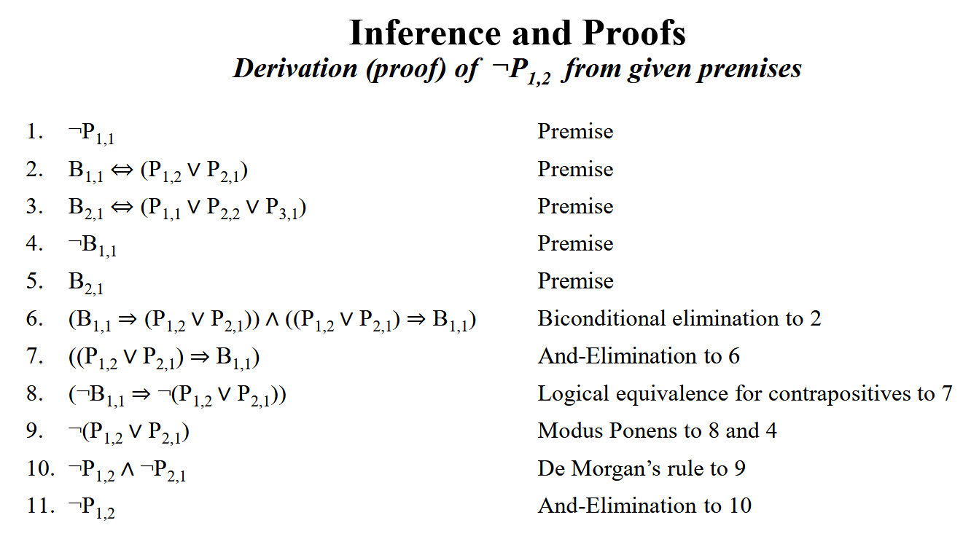
Proof by Resolution
1. What are we trying to say?
- There are many inference rules in logic (like: Modus Ponens, Biconditional Elimination, etc.).
- Some rules are not enough alone to solve all possible logic problems.
Example:
If you remove "biconditional elimination" — you cannot solve some Wumpus World puzzles — because you can’t break "if and only if" into simple parts.
2. So what happens?
- Your proof system becomes incomplete — meaning:
- Even if a truth is hidden in KB, you may not be able to reach it because your rules are missing something.
3. What is special about Resolution?
Resolution is 1 rule — but very powerful.
If you use Resolution + a proper search method (like iterative deepening) — then:
- You can prove anything that is logically provable.
- The system is complete — no truth is unreachable!
4. Why Resolution = Complete?
Because Resolution:
- Can handle any logical problem when formulas are converted into CNF form.
- Can detect contradictions to prove statements by contradiction (unsatisfiability).
- So even if no other rules exist — Resolution alone is enough to prove everything that is provable.
Rules of Resolution
- Convert all statements to CNF (Conjunctive Normal Form)
- Negate the conclusion
- Apply Resolution repeatedly until you derive an empty clause

Clauses
In Resolution, you work with things called clauses.
What is a Clause?
A clause is a disjunction of literals.
Example:
- P ∨ R ∨ ¬Q ∨ ¬S
What is a Literal?
A literal is either an atomic sentence (a positive literal) or a negated atomic sentence (a negative literal)
Example Literals:
- P (positive literal)
- ¬Q (negative literal)
What is a Unit Clause?
A clause with only one literal.
Example:
- P
- Called a unit clause because it has only 1 item.
Why are Clauses Important in Resolution?
- Resolution only works on clauses.
- Before applying the Resolution Rule — you must:
  - Convert everything to CNF (Conjunctive Normal Form).
  - In CNF, each part is a clause (OR of literals).
  - Resolution picks two clauses and resolves using opposite literals.
Conjunctive Normal Form (CNF)
In logic, before we use the resolution method, the sentences must be written in a special form called Conjunctive Normal Form (CNF).
- Resolution rule works only when the statements are in this form.
- So, the Knowledge Base (KB) and the Query must also be in CNF.
What is CNF?
A sentence is in CNF when:
It is written as a AND ( ∧ ) of many clauses.
Each clause is a OR ( ∨ ) of literals.
Literals mean simple statements like P, Q, R or their negations like ¬P, ¬Q, ¬R.
Example:
(P ∨ Q) ∧ ( ¬R ∨ S)
This is in CNF because:
- There are two parts (P ∨ Q) and (¬R ∨ S) — they are ORs of literals.
- These parts are joined with AND ( ∧ ).
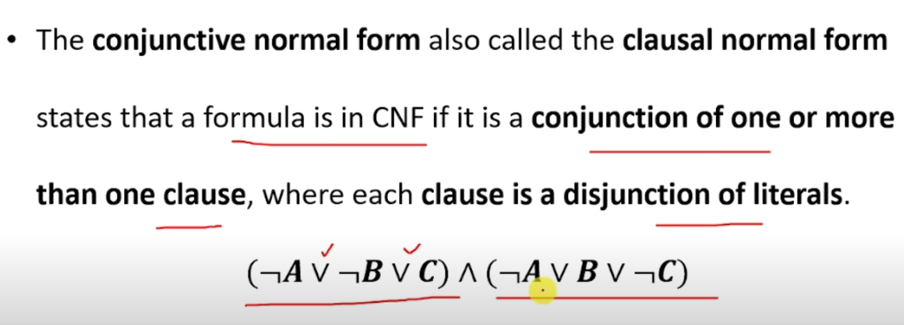
Steps to Convert Logical Sentences to CNF
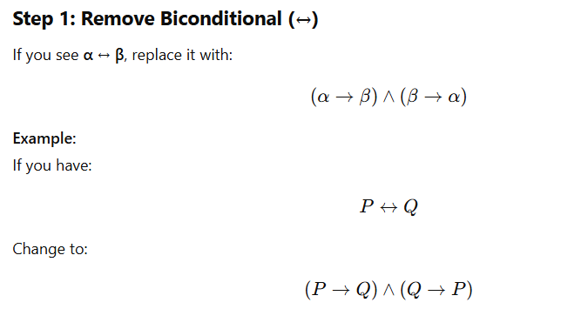

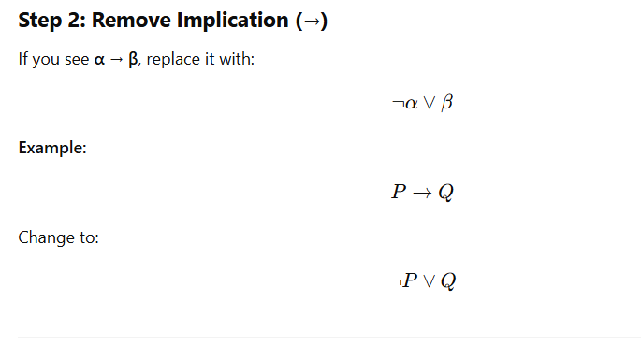

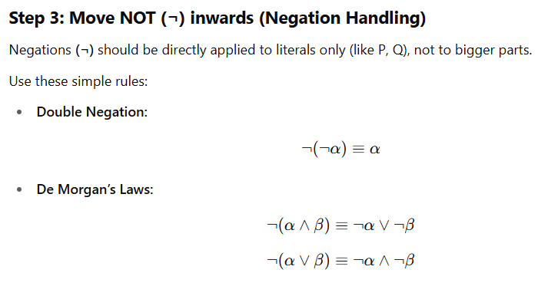
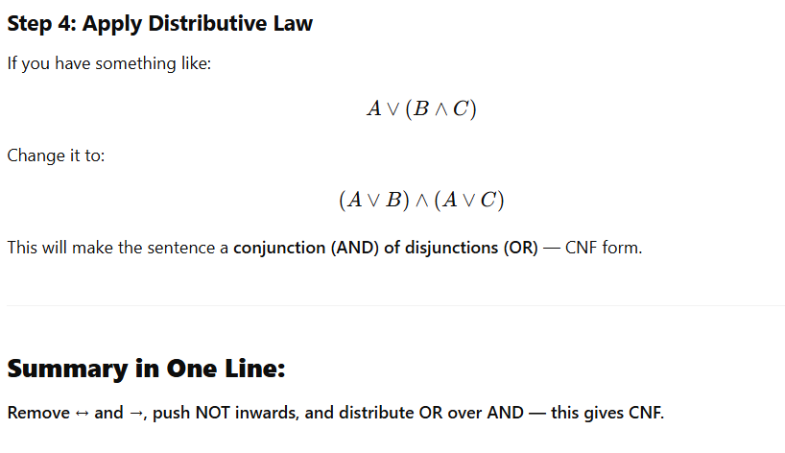

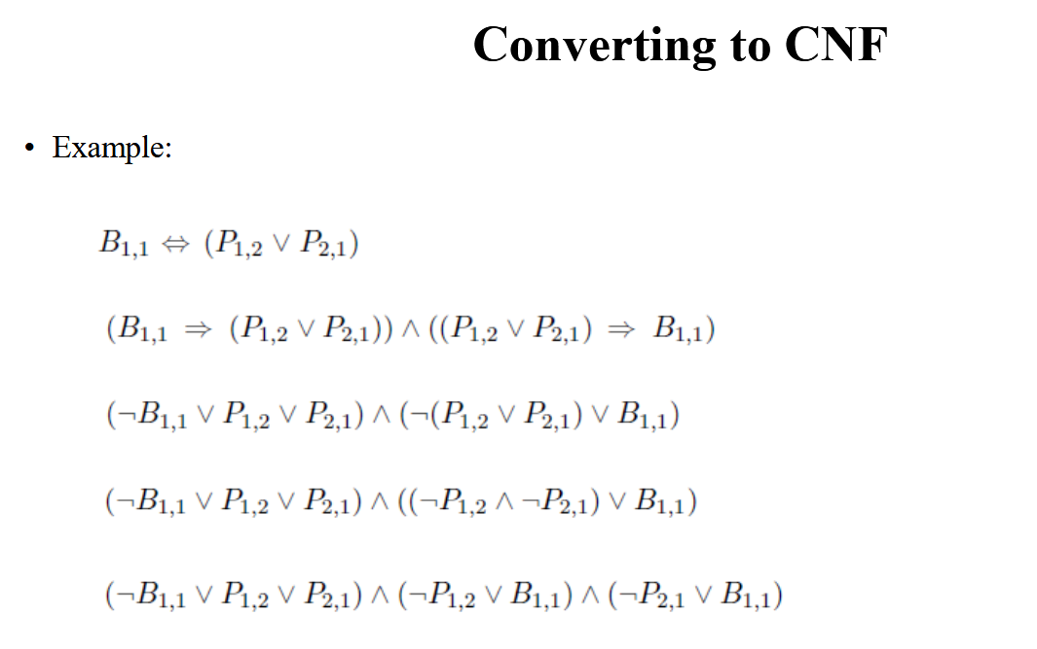
Horn Clauses and Definite Clauses
Definite Clause
A clause that has only one positive literal and the rest are negative.
Example:
¬P ∨ ¬Q ∨ R
Here, R is positive, the rest are negative — so this is a definite clause.
Horn Clause
A clause that has at most one positive literal (which means zero or one positive literal allowed).
So, all definite clauses are Horn clauses — but Horn clauses also allow having no positive literal.
Goal Clause
A clause with no positive literal — these are called goal clauses.
Example:
¬P ∨ ¬Q
This is a goal clause — because it has no positive literal.
Why are Definite Clauses Useful in Knowledge Bases?
1. Can be written as Implication:
Every definite clause can be written like:
(P ∧ Q ∧ R) → S
- The body is the condition (P ∧ Q ∧ R),
- The head is the result (S).
- If only S exists alone — it’s called a fact.
2. Inference is Easy:
Horn clauses allow Forward Chaining and Backward Chaining — these are used in Logic Programming (like Prolog) to find conclusions.
3. Fast Checking:
Checking if something is true (entailment) with Horn clauses is very fast — linear time depending on the size of the knowledge base.
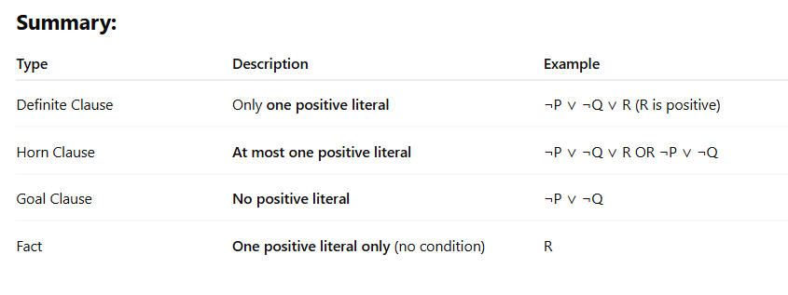
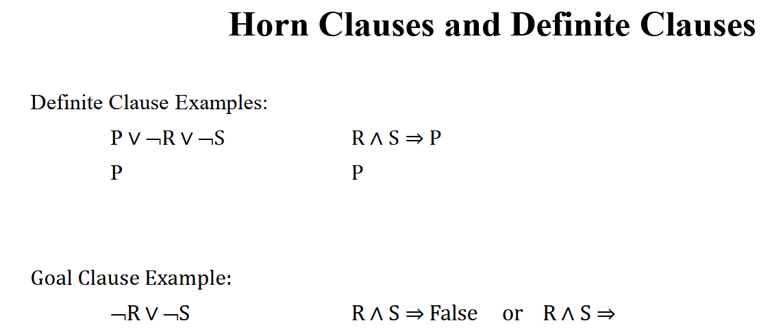
Forward and Backward Chaining
1. Forward Chaining
- Starts from the known facts in the knowledge base.
- Applies rules to find new facts until the required result (goal) is found.
Why we use it?
- To automatically deduce all possible conclusions from the given facts.
- Used when you have all data but want to know what can be derived.
Example:
Rules (Horn Clauses):
- If A and B, then C:
A ∧ B → C
- A is true (Fact)
- B is true (Fact)
Forward Chaining will apply Rule 1 and derive:
C is true.
2. Backward Chaining
- Starts from the goal (query) and tries to prove it by finding facts or rules that support it.
- Works backward from the goal to check if it can be derived.
Why we use it?
- To answer a specific question by checking if the goal can be reached using the facts and rules.
- Used when you want to prove or disprove a particular conclusion.
Example:
You want to check: Is C true?
Finds a rule:
A ∧ B → C
Then checks: Are A and B true?
If both are facts, then C is true.
